
MFCC-CNN Acoustic Sensing on ESP32 for Real-Time Water Leak Detection and Cloud Notification
FINAL YEAR
PROJECT PHASE-I REPORT
Submitted by
Bhuvanendiran P (23619203)
Gogulnath R (23619208)
Lalith Sharma A (23619217)
in partial fulfilment for the award of the degree of
BACHELOR OF TECHNOLOGY CSE -
ARTIFICIAL INTELLIGENCE AND MACHINE LEARNING

DEPARTMENT OF ARTIFICIAL INTELLIGENCE AND MACHINE LEARNING
SCHOOL OF ENGINEERING
VELS INSTITUTE OF SCIENCE, TECHNOLOGY AND ADVANCED STUDIES (VISTAS)
CHENNAI
OCTOBER 2026
BONAFIDE CERTIFICATE
Certified that this project “MFCC-CNN Acoustic Sensing on ESP32 for Real-Time Water Leak Detection and Cloud Notification” is the bonafide work of Bhuvanendiran P (23619203), Gogulnath R (23619208) and Lalith Sharma A (23619217) who carried out the project work under my supervision. Certified further that, to the best of my knowledge, the work reported here does not form part of any other project report or dissertation on the basis of which a degree or award was conferred on an earlier occasion on this or any other candidate.
SIGNATURE OF THE HOD  Dr. K. Ulagapriya, M.E., Ph.D.  Associate Professor & Head  Department of AI & ML  School of Engineering  VISTAS  Chennai - 600 117 | SIGNATURE OF THE SUPERVISOR  Ms. S.J. Kavitha, M.E., (Ph.D.)  Assistant Professor  Department of AI & ML  School of Engineering  VISTAS  Chennai - 600 117
Submitted for the Project Work and Viva-Voce examination held on ……………… at Vels Institute of Science, Technology and Advanced Studies (VISTAS), Chennai – 600 117.
INTERNAL EXAMINER | EXTERNAL EXAMINER
ACKNOWLEDGEMENT
It is certainly a great delight and proud privilege to acknowledge the help and support we received from the positive minds around us in making this venture a successful one. The infrastructural support with all kinds of lab facilities has been a motivating factor in the completion of this project work, all because of our FOUNDER & CHAIRMAN, Shri. Dr. ISHARI K. GANESH, and it is with great pleasure that we take this opportunity to thank him.
We are grateful to our HEAD OF THE DEPARTMENT, Dr. K. Ulagapriya, for her continuous support for the project, from initial advice and contacts in the early stages of conceptual inception, and through on-going advice and encouragement to this day. We extend our warmest thanks to our INTERNAL GUIDE, Ms. S.J. Kavitha, Assistant Professor, Department of AI & ML, who has patiently guided us and provided invaluable advice and help throughout the work. We are thankful to our Project Coordinator, Ms. S.M.Sowmiya.
We would like to express our greatest gratitude to our staff members, Librarian, and non-teaching staff members of the Computer Centre, who have helped and supported us throughout. Last but not the least, we wish to thank our parents and friends for their individual support and interest, who inspired and encouraged us to go our own way; without them we would be unable to complete this project.
BHUVANENDIRAN P 23619203
GOGULNATH R 23619208
LALITH SHARMA A 23619217
TABLE OF CONTENTS
ABSTRACT i
LIST OF FIGURES ii
LIST OF ABBREVIATIONS iii
LIST OF TABLES iv
INTRODUCTION 1
1.1 Background 1
1.2 Motivation 1
1.3 Problem Statement 2
1.4 Objectives of the Project 2
1.5 Scope of Phase 01 3
1.6 Contributions 3
1.7 Organisation of the Report 3
LITERATURE SURVEY 4
2.1 Overview 4
2.2 Acoustic Leak Detection in Distribution Networks 4
2.3 Deep Learning Approaches 4
2.4 IoT and Edge-Based Leak Detection 5
2.5 Household Leak Detection 5
2.6 Summary of Reviewed Works 6
2.7 Research Gap Analysis 6
SYSTEM ANALYSIS 8
3.1 Existing System 8
3.2 Proposed System 8
3.3 Feasibility Study 9
3.4 Requirement Specification 9
3.5 Hardware Requirements 10
3.6 Software Requirements 11
SYSTEM DESIGN 13
4.1 Design Overview 13
4.2 System Architecture 13
4.3 Block Diagram 14
4.4 Flow Chart 14
4.5 Hardware Design 15
4.6 Processing Service and Data Flow 16
4.7 Sound Classes 16
4.8 Leak Confirmation Logic 17
4.9 Cloud Database Design 18
4.10 Notification Design 19
4.11 Dashboard Design 19
IMPLEMENTATION 20
5.1 Implementation Overview 20
5.2 Module 1: Dataset Collection and Preparation 20
5.3 Module 2: Audio Pre-Processing 21
5.4 Module 3: Feature Extraction 22
5.5 Module 4: CNN Model Development 23
5.6 Module 5: Hardware Integration 25
5.7 Module 6: Firebase Integration 25
5.8 Module 7: Dashboard Development 26
5.9 Module 8: Notification System 26
5.10 Working of the Prototype 27
RESULTS AND DISCUSSION 28
6.1 Evaluation Plan and Metrics 28
6.2 Results of the CNN Model 28
6.3 Results of the MFCC Model 30
6.4 Comparison of the MFCC and CNN Models 31
6.5 Target Versus Measured Performance 33
6.6 Prototype Demonstration on the Dashboard 33
6.7 Live Test Scenarios 35
6.8 Threats to Validity 35
CHALLENGES, LIMITATIONS AND PROJECT STATUS 37
7.1 Challenges Faced 37
7.2 Limitations 38
7.3 Cost and Energy 38
7.4 Applications 38
7.5 Deployment Considerations 39
7.6 Project Status at the End of Phase 01 39
CONCLUSION AND FUTURE SCOPE 40
8.1 Conclusion 40
8.2 Plan for Phase 02 40
8.3 Future Scope 41
REFERENCES 42
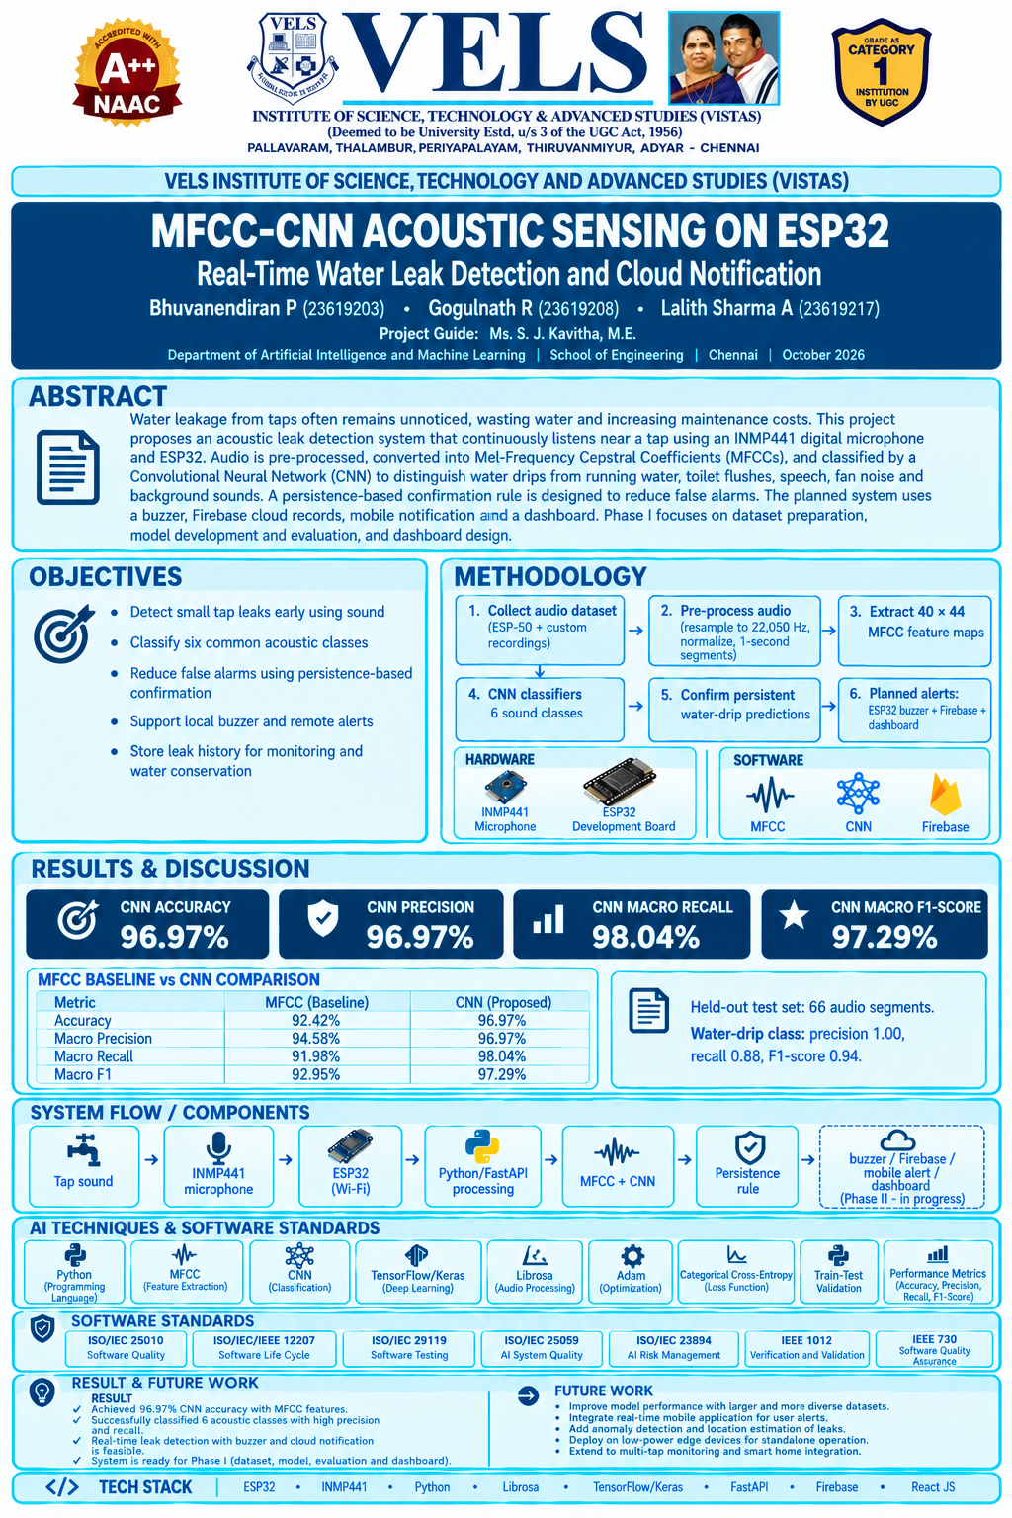

ABSTRACT
Water leakage from taps is a major source of water wastage in residential buildings, hostels, offices, and public restrooms. Minor leaks often remain unnoticed for long periods, leading to unnecessary water loss and increased maintenance expenses. Conventional leak detection methods commonly rely on moisture sensors or flow sensors, which may not effectively detect small dripping leaks at an early stage. This work presents an acoustic-based water leakage detection and notification system that continuously monitors sounds near a tap using a microphone sensor. The captured audio signals are processed and classified using a Convolutional Neural Network (CNN) model to differentiate water dripping sounds from other environmental noises such as human speech, fan noise, and running water. Upon detecting a continuous leakage event, the system activates a local alarm and sends a notification to the user through a mobile application. Leak information is stored in a cloud database for monitoring and future analysis. The proposed system provides an automated approach for early leak detection and water conservation. By identifying leakage in its initial stage and generating timely alerts, the system helps reduce water wastage and supports effective water resource management.
Keywords: Water Leakage Detection, Acoustic Signal Processing, Convolutional Neural Network, Internet of Things, Water Conservation.

LIST OF FIGURES
Figure 1.1 Estimated daily water loss from a dripping tap 2
Figure 4.1 System architecture 13
Figure 4.2 Block diagram of the proposed system 14
Figure 4.3 Flow chart of the proposed system 15
Figure 4.4 INMP441, buzzer and ESP32 connections 15
Figure 4.5 Run-length leak confirmation rule (illustration) 17
Figure 4.6 Example of a Firebase event record 19
Figure 5.1 Class-wise folders of the audio dataset 21
Figure 5.2 Test segments per class 21
Figure 5.3 MFCC feature extraction pipeline 22
Figure 5.4 Architecture of the CNN classifier 23
Figure 5.5 Console output of the evaluation run 25
Figure 5.6 Landing page of the AquaSense dashboard 26
Figure 6.1 Per-class scores of the CNN model 29
Figure 6.2 Confusion matrix of the CNN model 30
Figure 6.3 Confusion matrix of the MFCC model 31
Figure 6.4 Overall metrics of the two models 32
Figure 6.5 F1-score per class of the two models 32
Figure 6.6 Analysis page: leak detected 34
Figure 6.7 Analysis page: no leak detected 34

LIST OF ABBREVIATIONS
S.No | Abbreviation | Full Form
1 | AI | Artificial Intelligence
2 | API | Application Programming Interface
3 | CNN | Convolutional Neural Network
4 | DNN | Deep Neural Network
5 | ESC-50 | Environmental Sound Classification (50 classes)
6 | FFT | Fast Fourier Transform
7 | FN | False Negative
8 | FP | False Positive
9 | GND | Ground
10 | GPIO | General-Purpose Input/Output
11 | HTTP | HyperText Transfer Protocol
12 | I²S | Inter-IC Sound
13 | IDE | Integrated Development Environment
14 | IoT | Internet of Things
15 | JSON | JavaScript Object Notation
16 | KB | Kilobyte
17 | LED | Light Emitting Diode
18 | MB | Megabyte
19 | MEMS | Micro-Electro-Mechanical Systems
20 | MFCC | Mel-Frequency Cepstral Coefficients
21 | ML | Machine Learning
22 | NRW | Non-Revenue Water
23 | ReLU | Rectified Linear Unit
24 | SCK | Serial Clock
25 | SD | Serial Data
26 | SVM | Support Vector Machine
27 | TN | True Negative
28 | TP | True Positive
29 | VDD | Positive Supply Voltage
30 | WAV | Waveform Audio File Format
31 | WS | Word Select

LIST OF TABLES
Table 2.1 Comparison with representative related work 5
Table 2.2 Summary of reviewed literature 6
Table 2.3 Research gap analysis 7
Table 3.1 Comparison with conventional approaches 8
Table 3.2 Hardware requirements of the prototype 10
Table 3.3 Software requirements and purpose 11
Table 4.1 Signals between components 15
Table 4.2 Audio data volume per second 16
Table 4.3 Sound classes used for training 16
Table 4.4 Leak confirmation algorithm 17
Table 4.5 Effect of the decision parameters 18
Table 4.6 Fields of a leak event record 19
Table 4.7 Dashboard modules 19
Table 5.1 Module-wise implementation progress 20
Table 5.2 Pre-processing steps and purpose 22
Table 5.3 MFCC extraction parameters 23
Table 5.4 Layer-wise summary of the CNN 23
Table 5.5 Training configuration 24
Table 6.1 Per-class results of the CNN model 28
Table 6.2 Per-class results of the MFCC model 30
Table 6.3 Overall comparison of MFCC and CNN models 31
Table 6.4 Target and measured performance 33
Table 6.5 Live test scenarios 35
Table 7.1 Challenges faced and solutions adopted 37
Table 7.2 Status of the Phase 01 deliverables 39
Table 8.1 Planned work for Phase 02 40

CHAPTER 1
INTRODUCTION

1.1 Background
Water is usually noticed only when it is scarce or unavailable, yet a significant portion of the water that utilities collect and purify never reaches a paying customer. Non-Revenue Water (NRW) averages about 35% in Asian cities, and the total cost to urban utilities in Asia has been estimated at nine billion US dollars a year [1]. Most research and engineering effort has therefore been directed at the mains and service pipes of the distribution network. The taps and fittings inside buildings receive far less attention, even though they are the place where most people actually meet the problem of leakage.
A dripping tap is easy to overlook. In hostels, offices, schools, hotels and public washrooms, no one feels responsible for a particular tap, and a slow drip may continue until the washer is replaced or the next water bill arrives. Because such leaks are small and continuous, they rarely trigger the alarms of conventional monitoring systems, but over weeks and months they add up to a considerable waste of water, higher utility bills and avoidable maintenance cost.
Recent progress in low-cost MEMS microphones, Wi-Fi enabled microcontrollers, deep learning and cloud platforms makes it practical to build a small, inexpensive node that listens to a tap continuously and tells a person when something is wrong. This project, “MFCC-CNN Acoustic Sensing on ESP32 for Real-Time Water Leak Detection and Cloud Notification”, explores exactly such a system. This report documents the work completed in Phase 01 of the project.

1.2 Motivation
The scale of the problem can be appreciated with a simple calculation. Assuming roughly 0.05 mL per drop, one drop every second adds up to about 4.3 litres a day, or nearly 1,580 litres in a year, from a single tap. Faster drips lose proportionally more, as shown in Figure 1.1. Studies of residential demand put leaks somewhere between 2% and 13% of total household consumption [4].
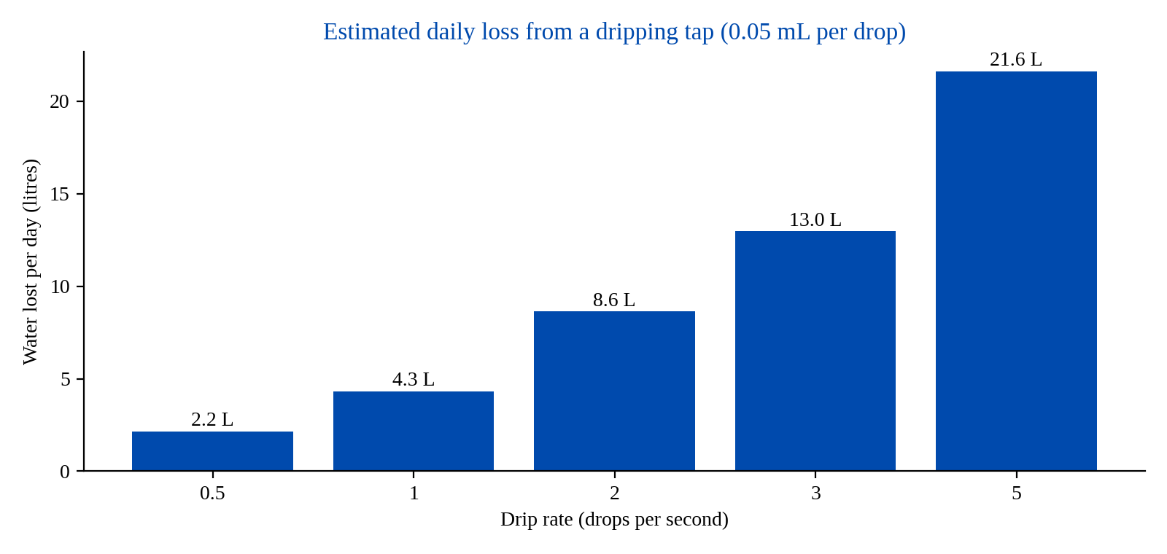
Figure 1.1: Estimated daily water loss from a dripping tap at different drip rates (assuming 0.05 mL per drop).
The traditional means of detection are of little help in this situation. Flow and pressure sensors do not measure a drip; they measure a burst. Moisture sensors report only water that has already gathered on a surface. Listening to a pipe with an acoustic rod works for utilities, but it depends on the skill and alertness of the person holding the rod [2], [3]. What is required instead is a device that sits close to the tap, listens to it continuously, recognises the sound of a drip, and notifies a person when the drip has been running for too long.

1.3 Problem Statement
Small water leaks from taps often go unnoticed for long periods, resulting in water wastage, increased utility bills, environmental impact and maintenance issues. Traditional sensor-based systems may fail to detect small dripping leaks effectively. Therefore, there is a need for an intelligent, real-time system capable of identifying water leaks at an early stage using sound recognition technology, and of informing users immediately so that corrective action can be taken.

1.4 Objectives of the Project

1.4.1 Primary Objective
To develop an AI-based system that detects water leakage from taps using acoustic signals and automatically sends alerts to users.

1.4.2 Secondary Objectives
- Reduce water wastage by detecting leaks at an early stage.
- Provide real-time leak detection through continuous acoustic monitoring.
- Generate instant notifications through a local buzzer and remote alerts.
- Estimate water loss caused by detected leaks.
- Maintain leak history and analytics for maintenance planning.
- Improve water conservation efforts in buildings with many taps.

1.5 Scope of Phase 01
The project is carried out in two phases. Phase 01, reported here, covers dataset collection, audio pre-processing, MFCC feature extraction, development and evaluation of the CNN classifier, the leak confirmation logic, the cloud database schema and the web dashboard. Hardware integration of the ESP32 node, Firebase integration and the complete notification workflow are in progress and will be finalised in Phase 02 together with extended live testing at real taps.

1.6 Contributions
The main contributions of the work reported here are the following:
- An end-to-end system design that combines acoustic sensing, deep learning, IoT communication, cloud storage and a monitoring dashboard for tap-level leak detection.
- A six-class CNN that distinguishes a dripping tap from running water, toilet flushing, human speech, fan noise and background sound using MFCC features.
- A temporal confirmation rule that converts frame-level predictions into a leak event only when the drip persists, reducing the probability of false alarms.
- A clear evaluation plan with target metrics, so that the prototype can be tested repeatedly with the same results, together with measured results on a held-out test set.

1.7 Organisation of the Report
Chapter 2 reviews related work and the research gap. Chapter 3 analyses the existing and proposed systems and lists the requirements. Chapter 4 describes the system design. Chapter 5 explains the implementation of each module. Chapter 6 reports and discusses the results. Chapter 7 covers challenges, limitations and project status, and Chapter 8 concludes with the future scope and the plan for Phase 02.

CHAPTER 2
LITERATURE SURVEY

2.1 Overview
Acoustic leak detection has a long history in water utilities. A leak in a pressurised pipe produces vibrations and sound that propagate along the pipe wall and through the water, and these signals can be picked up by hydrophones, accelerometers, contact microphones or even simple listening rods. Over the last decade, machine learning and deep learning have been added to this process so that the decision about whether a recording contains a leak no longer depends only on a trained human ear. This chapter reviews the representative work in this area and then identifies what is still missing for leak detection at the level of an individual tap.

2.2 Acoustic Leak Detection in Distribution Networks
Vanijjirattikhan et al. built an AI-assisted system for the Metropolitan Waterworks Authority of Bangkok in which an operator records sound from a buried service pipe with an acoustic rod and a smartphone [2]. The audio is transformed with an FFT, averaged over 14 frames, normalised and classified. Comparing SVM, DNN and CNN on 108,481 samples from 688 leak and 619 non-leak sites, they reported test accuracies of 78.29%, 94.89% and 94.71%, respectively. In field trials, novice operators using the device reached 97.83% accuracy against 95.56% for experts. Their work shows that a learned classifier can stand in for a trained ear, and it also shows how much care is needed when splitting data: samples were grouped by site so that one site never appeared in both the training and test sets.
Gunatilake and Valls went a step further and classified the type of leak from vibro-acoustic signals in a live urban network, with accuracies of up to 98% [9]. Martinez-Rios et al. compared wavelet-scattering features computed from accelerometer, hydrophone and pressure data and found that an SVM on accelerometer features performed best, with 89.58% and 96.67% accuracy on looped and branched test networks [10].

2.3 Deep Learning Approaches
Several groups have applied deep networks to leak sound. Kang et al. combined a 1D CNN with an SVM for leak recognition and added graph-based localisation [5]. Müller et al., Arunsuriyasak et al. and Nam et al. worked with image-like representations of sound, such as recurrence plots, Mel-spectrograms and MFCCs, which CNNs handle well [6]–[8]. Nam et al. in particular trained a CNN on actual leak sounds and evaluated it with the hold-out method [7]. The common observation in these studies is that converting audio into a time–frequency map and feeding it to a convolutional network is an effective way to separate leak signatures from ambient noise. The same idea is adopted in the present work, with MFCC maps as the network input.

2.4 IoT and Edge-Based Leak Detection
Closer to the present setting, Islam et al. developed a low-power IoT node that listens through a piezoelectric contact microphone, runs a quantised model of about 11 KB and reported 98.96% accuracy; the node beeps and forwards an alert when it hears a leak [11]. Their work demonstrates that acoustic leak detection can be combined with an inexpensive embedded device and an alerting mechanism. However, the sensor is attached to pipes, and the evaluation concerns home and industrial pipes rather than an air-borne microphone listening to a tap in a room.

2.5 Household Leak Detection
Zese et al. took a different route for household plumbing and used neural networks on smart-meter consumption data to detect intra-domestic leaks of different sizes [4]. Flow-based approaches of this kind can reveal that a leak exists somewhere in a dwelling, but they depend on the presence of a smart meter, and very small drips are hard to separate from normal consumption. Table 2.1 compares the proposed system with the representative related work discussed in this chapter.
Table 2.1: Comparison of the proposed system with representative related work.
Ref. | Sensing / data | Method | Setting
[2] | Acoustic rod, phone mic | FFT; SVM, DNN, CNN | Buried service pipes
[9] | Vibro-acoustic | Multiclass time-frequency CNN | Urban water mains
[10] | Accelerometer, hydrophone, pressure | Wavelet scattering, SVM | Test pipe networks
[4] | Smart-meter flow data | Neural networks | Household plumbing
[11] | Piezo contact mic | Quantised edge ML | Home / industrial pipes
Proposed | INMP441 air microphone | MFCC + CNN, temporal rule | Indoor tap, cloud alerts

2.6 Summary of Reviewed Works
Table 2.2 summarises the methodology, findings and limitations of the works reviewed during the project survey. Taken together they show that acoustic and flow-based techniques are mature for pipelines and distribution networks, while support for household and bathroom taps remains limited.
Table 2.2: Summary of reviewed literature.
S.No | Paper title | Methodology | Findings | Limitations
1 | AI-based Acoustic Leak Detection in Water Distribution Systems (2022) | Acoustic sensors with AI-based sound classification | Detected water leaks using acoustic signals and machine learning. | Targets large pipelines; no household-level monitoring.
2 | Interpretable Deep Learning for Acoustic Leak Detection in Water Distribution Systems (2025) | CNN-based deep learning model | High accuracy in classifying leak sounds from pipelines. | Needs specialised equipment; industrial environments.
3 | Acoustic-Based Leak Detection and Localization Using Deep Learning (2025) | Acoustic sensing with deep neural networks | Detects leaks and estimates their location. | High implementation cost; complex deployment.
4 | IoT-Based Smart Water Monitoring and Leak Detection System (2025) | Flow sensors with IoT devices | Real-time monitoring of consumption and leaks. | Cannot effectively identify minor dripping leaks.
5 | Smart Water Leakage Detection Using Wireless Sensor Networks (2017) | Wireless sensor network and flow monitoring | Continuous monitoring and leak identification. | Depends on flow measurement, not acoustic analysis.

2.7 Research Gap Analysis
Most published systems target buried pipes or large networks and rely on specialist sensors, contact microphones or operator-held tools. A permanently mounted, inexpensive microphone that listens for tap leakage in an indoor room brings its own difficulty: the room is full of other sounds. Speech, fans and toilet flushes all overlap with the frequencies of running or dripping water. No published work was found that combines low-cost tap-level acoustic detection, a classifier trained to reject these confounding sounds, and cloud notification with a dashboard. This is the gap addressed here and is summarised in Table 2.3.
Table 2.3: Research gap analysis.
Existing systems | Identified gap
Mainly focused on underground pipelines and industrial water networks. | Lack of solutions for household and bathroom tap leakage detection.
Depend on flow sensors and moisture sensors; small dripping leaks are difficult to detect at an early stage. | Need for early detection of small drips using sound.
Limited real-time user notification mechanisms. | Need for instant mobile alerts and cloud monitoring.
Expensive infrastructure and deployment costs. | Requirement for a low-cost IoT-based solution.
Focus on leak detection only. | Need for water conservation analytics and monitoring.

CHAPTER 3
SYSTEM ANALYSIS

3.1 Existing System
Water leakage at taps is currently handled through a mixture of manual inspection and general-purpose sensors. Each of these approaches has characteristic strengths and weaknesses for the case of a small, continuous drip.
- Flow sensors: measure the volume or rate of water passing through a pipe. A drip is far below the resolution of ordinary flow sensors, so they report a burst but often miss small drips.
- Moisture sensors: detect water only after it has gathered on a surface. The leak is therefore noticed late, after water has already been wasted.
- Manual acoustic inspection: a person listens to the pipe with an acoustic rod. This approach is accurate only when the person holding the rod is skilled and alert, and it cannot run continuously.
Table 3.1 compares the proposed system with these conventional approaches.
Table 3.1: Comparison of the proposed system with conventional approaches.
Approach | Small drips | Continuous | Skill needed
Flow sensor | Often missed | Yes | Low
Moisture sensor | After water pools | Yes | Low
Manual acoustic rod | Yes, but operator dependent | No | High
Proposed system | Yes (target) | Yes | Low

3.2 Proposed System
The proposed system continuously monitors the sound near a tap. An INMP441 digital microphone connected to an ESP32 controller captures the sound and streams it over Wi-Fi to a Python service. The service resamples the audio, divides it into one-second segments, computes a 40 × 44 MFCC map for each segment and passes it to a CNN. The CNN classifies the segment into one of six classes: water drip, running water, flush sound, human speech, fan noise and background noise. Only the water-drip class can contribute to a leak decision. When the drip persists for a pre-defined duration, the system sounds a local buzzer, records the event in Firebase, sends a notification to the user and updates the dashboard.
The design has several advantages. The sensing node is inexpensive and mains powered. Because the processing is done by a separate service, a new model can be trained on a laptop or server and simply placed in the service without touching the firmware. Each node carries a location label that is attached to every record, so that a notification can state exactly which tap is leaking.

3.3 Feasibility Study

3.3.1 Technical Feasibility
All technologies required for the system are mature and openly available. The ESP32 provides an I²S peripheral for reading the digital microphone and a Wi-Fi radio for communication. Python, TensorFlow/Keras and Librosa provide the complete audio-to-model pipeline, and Firebase provides real-time synchronisation, notifications and cloud storage. The experiments conducted in Phase 01 show that a compact CNN is sufficient to separate the sound classes, which confirms the technical feasibility of the approach.

3.3.2 Economic Feasibility
The bill of materials is small: a microcontroller board, a MEMS microphone breakout and a buzzer. The server side can run on any small machine or on a shared cloud instance serving many nodes at once, so the cost per tap decreases as more taps are monitored. Compared with the cost of the water lost through an unnoticed leak and the cost of replacing specialised sensors, the investment is modest.

3.3.3 Operational Feasibility
The node is installed near a tap and needs only a power supply and a Wi-Fi connection. Alerts are delivered through the buzzer and the dashboard, and no skill is needed to interpret them. The model can be retrained as new field recordings are confirmed.

3.4 Requirement Specification

3.4.1 Functional Requirements
- Capture audio continuously from the microphone placed near the tap.
- Pre-process the audio and extract MFCC features for each one-second segment.
- Classify each segment into one of the six sound classes.
- Confirm a leak only if the drip persists for the configured duration.
- Activate a local buzzer and send a remote notification when a leak is confirmed.
- Store every leak event, with time, location, class, confidence and severity, in the cloud database.
- Provide a dashboard with login, live status, leak history and analytics.

3.4.2 Non-Functional Requirements
- Accuracy: the classifier should exceed 90% on accuracy, precision, recall and F1-score on the held-out test set.
- Responsiveness: the alert should be generated within a few seconds after the drip crosses the confirmation time.
- Low false-alarm rate: normal use such as speech, running water, flushing and fans must not trigger the alarm.
- Low cost and low power: inexpensive hardware powered by a standard 5 V supply.
- Privacy: raw audio should be discarded immediately after feature extraction, and only features and predictions retained.
- Maintainability: the model must be replaceable without modifying the firmware.

3.5 Hardware Requirements
The hardware required for the prototype is listed in Table 3.2, and the role of each component is described below.
Table 3.2: Hardware requirements of the prototype.
Component | Quantity | Purpose
ESP32 development board | 1 | Main controller; reads microphone and drives buzzer
INMP441 MEMS microphone | 1 | Digital I²S microphone for audio capture
Buzzer | 1 | Local leak alarm
LEDs | 2 | Status indication
Breadboard | 1 | Prototype wiring
Jumper wires | As required | Interconnections
Power supply | 1 | 5 V supply for the ESP32 board

3.5.1 ESP32 Development Board
The ESP32 development board is the main controller of the sensing node. It has a dual-core processor, built-in Wi-Fi, reasonable power consumption, support for IoT work and a low price. In this design it is used for three purposes: reading the microphone through its I²S peripheral, sending the audio to the processing service, and actuating the buzzer when the service reports a confirmed leak. Keeping the controller’s duties this small avoids the cost of a larger board.

3.5.2 INMP441 Digital Microphone
The INMP441 is a MEMS microphone with a digital I²S output. Because the signal is digitised inside the microphone, the analogue hum that is picked up by wiring to an analogue microphone does not reach the ESP32. The inexpensive device is sensitive enough to hear a single drop falling. It should be mounted some distance from the spout and kept away from fans and vents wherever possible.

3.5.3 Buzzer, LEDs and Power
A small buzzer provides a prompt local warning, which matters in places such as a washroom where the person nearby may not have a phone. Two LEDs indicate the operating state. The whole node is powered from the 5 V supply of the ESP32 board, which allows it to be placed within easy reach of the tap.

3.6 Software Requirements
The software used in the prototype and the purpose of each item are listed in Table 3.3.
Table 3.3: Software requirements and their purpose.
Software | Purpose
Python | AI model development and processing service
TensorFlow / Keras | Deep learning: training, evaluation and inference of the CNN
Librosa | Audio loading, resampling, MFCC extraction
FastAPI | Receives audio from the node, runs the pipeline, replies with status
Arduino IDE | ESP32 programming
Firebase | Cloud database, real-time synchronisation and notifications
React JS | Dashboard development
Visual Studio Code | Development environment

CHAPTER 4
SYSTEM DESIGN

4.1 Design Overview
The design follows a modular pipeline in which every stage has a single responsibility: sensing, transmission, pre-processing, classification, confirmation, alerting and storage. The sensing node is deliberately simple and the heavier processing is carried out by a separate service, which makes the system easy to implement and test module by module.

4.2 System Architecture
The overall architecture is shown in Figure 4.1. Sound from the water tap (drinking water, bathroom water or running water) is captured by the microphone sensor. The ESP32 collects the microphone signal and sends the audio for processing. The audio pre-processing stage applies noise reduction, filtering, segmentation and MFCC feature extraction. The CNN classifier labels the sound as water tap sound, running water, flush sound, human speech, fan noise or another environmental sound. If a water tap sound is detected, the water usage / leak detection logic is applied, a user alert is generated, and the buzzer, mobile alert, dashboard and Firebase record are updated. For all other sounds the system raises no alert, keeps listening and repeats the process.
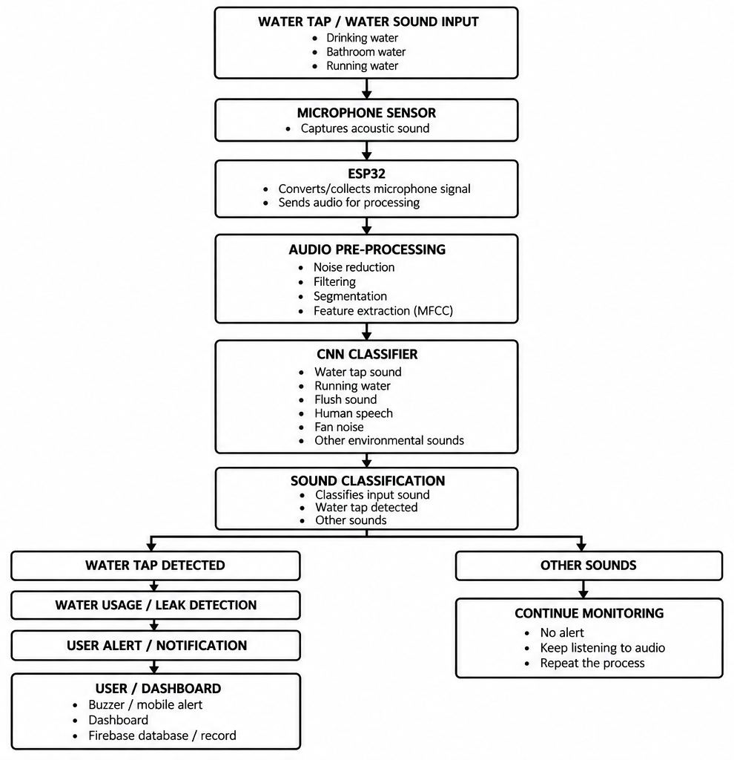
Figure 4.1: System architecture of the acoustic leak detection and notification system.

4.3 Block Diagram
The block diagram in Figure 4.2 shows the same system as a left-to-right flow. The hardware blocks (input source, microphone sensor and ESP32) feed the AI processing blocks (audio pre-processing and CNN classifier), which are implemented in software. The classification output then splits into two paths. A detected water tap sound leads to the water usage / leak detection block and then to the alert system (buzzer and mobile notification through Firebase or Twilio), the cloud database (Firebase) and finally the user dashboard for web and mobile. Other sounds lead to continued monitoring with no alert.
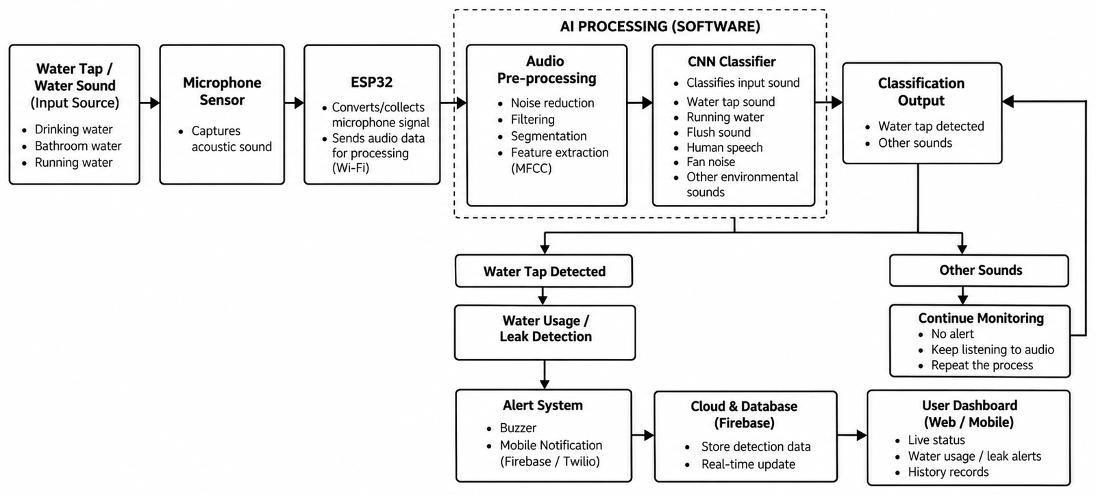
Figure 4.2: Block diagram of the proposed system.

4.4 Flow Chart
The operation of the system is summarised by the flow chart in Figure 4.3. The loop starts by capturing the water sound with the microphone, collecting it at the ESP32 and sending it for processing. After pre-processing the CNN classifies the sound, and the decision “Is it water tap sound?” selects between the alert path and the continue-monitoring path. Figure 4.3 shows the basic decision path only. In the implemented system a positive classification does not trigger the alarm by itself: it is first passed to the leak-confirmation logic of Section 4.8, which declares a leak only when the drip persists for the configured duration. The water tap sound in the chart corresponds to the Water Drip class of Table 4.3.
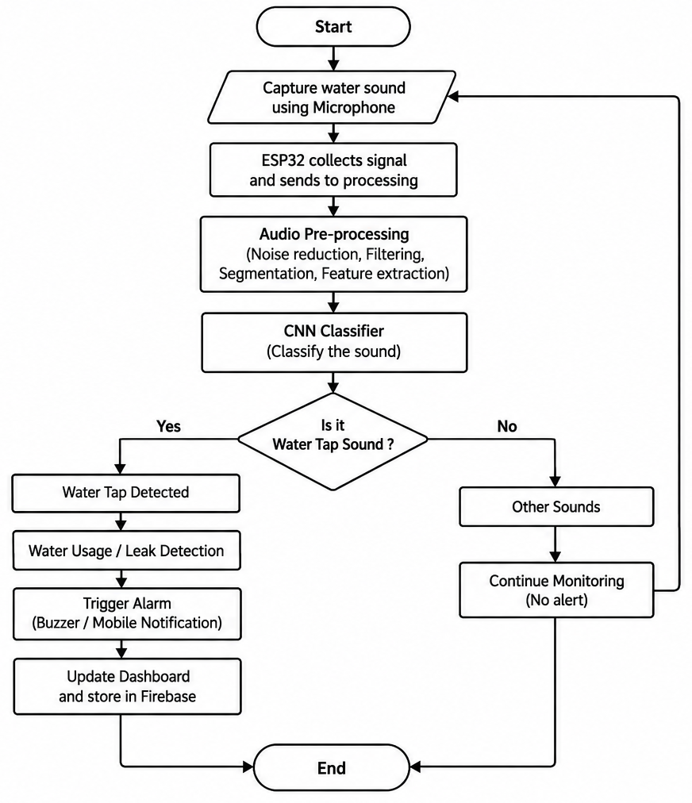
Figure 4.3: Flow chart of the proposed system.

4.5 Hardware Design
The connection between the components is shown in Figure 4.4. The INMP441 microphone is connected to the ESP32 through the I²S signals SCK, WS and SD, is powered from 3.3 V and ground, and has its L/R pin tied to ground so that it outputs on the left channel. The buzzer is driven from a GPIO pin of the ESP32. The ESP32 communicates over Wi-Fi with the FastAPI server and Firebase, sending audio and receiving the result.
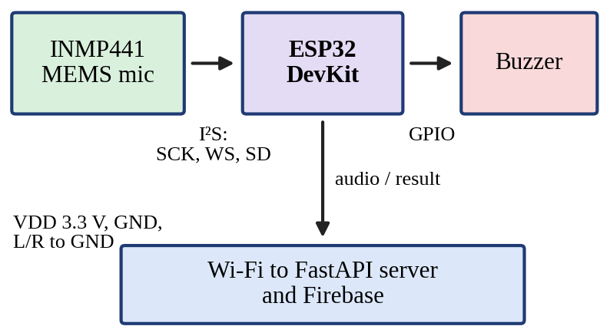
Figure 4.4: Connection of the INMP441 microphone and buzzer to the ESP32, with the Wi-Fi link to the server and Firebase.

Table 4.1 lists the signals exchanged between the microphone, the ESP32 and the buzzer.
Table 4.1: Signals between the microphone, ESP32 and buzzer.
Connection | Signals | Remarks
INMP441 → ESP32 | SCK, WS, SD (I²S) | Digital audio stream
INMP441 supply | VDD 3.3 V, GND | L/R pin to GND (left channel)
ESP32 → Buzzer | GPIO | Local leak alarm
ESP32 ↔ Server | Wi-Fi (HTTP) | Audio upload, status reply
Server → Cloud | Firebase | Events, notifications, dashboard data

4.6 Processing Service and Data Flow
The link between the node and the server is deliberately simple. The ESP32 reads 16-bit samples from the microphone and uploads them to the FastAPI service in short chunks over HTTP. One second of audio sampled at 44.1 kHz with 16 bits per sample occupies about 88 KB, which a normal Wi-Fi connection carries without difficulty. On arrival, the service resamples the audio to 22,050 Hz, slices it into one-second chunks, computes the MFCC map and runs the CNN. The prediction is passed to the confirmation logic, and the service replies with a small status message so that the ESP32 can switch the buzzer on or off. Table 4.2 summarises the volume of audio data at the node and at the model.
Table 4.2: Audio data volume per second at the node and at the model.
Parameter | At the ESP32 upload | At the model input
Sampling rate | 44.1 kHz | 22,050 Hz (resampled)
Sample width | 16 bit | 32-bit float (normalised)
Data for one second | about 88 KB | 40 × 44 MFCC map

This arrangement has two consequences. First, a new model can be trained on a laptop or server and simply placed in the service, similar to the cloud-managed model updates used in [2], except that a fixed node is used rather than a handheld device. Second, each node is assigned a location label at installation time, and this label travels with each record so that a notification can specify the exact tap.

4.7 Sound Classes
The classifier recognises six sound classes. They were chosen because they are the sounds most likely to be heard near a tap in a bathroom, hostel or office and because several of them overlap in frequency with dripping or running water.
Table 4.3: Sound classes used for training.
Class | Meaning | Source
Water Drip | Leak sound | Custom + public
Running Water | Normal flow | Custom + public
Flush Sound | Toilet flushing | Public + custom
Human Speech | Human voices | Custom recordings
Fan Noise | Electrical fan | Custom recordings
Background Noise | Resolved ambient noise | Custom + public

4.8 Leak Confirmation Logic
A single segment classified as a drip does not necessarily mean that there is a leak; someone may only have just turned the tap off. The system therefore looks for persistence. Let p_{d}(t) be the CNN probability of the water-drip class for segment t. A segment counts as positive when drip is the top class and its probability is at least a threshold θ:
s(t) = 1 if argmax = drip and p_{d}(t) ≥ θ, else 0 (4.1)
A run-length counter follows the positive segments:
r(t) = r(t − 1) + 1 if s(t) = 1, else 0 (4.2)
A leak is detected when r(t)·Δt ≥ T_{leak}, where Δt is the segment length (one second) and T_{leak} is the minimum duration allowed. Both θ and T_{leak} are tunable for each installation. In practice a short grace period of a few segments is helpful, so that one misclassified segment does not reset a long run. Figure 4.5 illustrates the rule: a short burst is ignored, while a sustained drip with one missed segment still reaches T_{leak} and is confirmed.
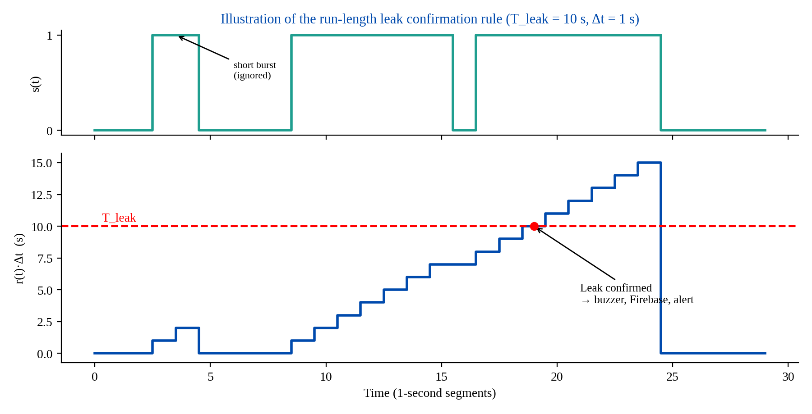
Figure 4.5: Illustration of the run-length confirmation rule (illustrative values: T_{leak} = 10 s, one-second segments, one-segment grace).
The complete procedure is given in Table 4.4.
Table 4.4: Leak confirmation algorithm.
Step | Action
1 | Capture a one-second audio segment from the microphone and pre-process it.
2 | Extract the 40 × 44 MFCC map and feed it to the CNN to obtain class probabilities.
3 | If the top class is water drip and p_{d}(t) ≥ θ, set s(t) = 1; otherwise set s(t) = 0.
4 | If s(t) = 1, update the counter r(t) = r(t − 1) + 1; otherwise reset r(t) = 0 after the grace period.
5 | If r(t)·Δt ≥ T_{leak}, declare a leak and proceed to Step 6; otherwise repeat from Step 1.
6 | Sound the buzzer, record the event in Firebase and notify the user.
7 | Update the dashboard and return to Step 1 to continue monitoring.

The procedure is started only by the drip class. Running water is considered normal use, and the other classes (flush, speech, fan and background) return the system to listening. This keeps the alarm quiet during normal washing and cleaning.

4.8.1 Choice of the Decision Parameters
The threshold θ and the duration T_{leak} control the balance between fast leak detection and avoiding nuisance alarms. The effect of each is summarised in Table 4.5. A high θ makes the system conservative, which reduces false alarms but may miss a slight leak. A low θ is more sensitive to small drips but allows more noise through. A short T_{leak} gives rapid warnings but can be triggered by a tap that has only just been closed, whereas a long T_{leak} produces fewer false alarms but postpones the warning. The values need to be tuned on recordings from the actual installation: a short T_{leak} can be used in a washroom that is empty at night, while a busy kitchen may need a longer one.
Table 4.5: Effect of the decision parameters.
Setting | Advantage | Drawback
High θ | Fewer false alarms | Slight drips may be missed
Low θ | Sensitive to small drips | More noise may be accepted
Short T_{leak} | Fast alert | Warning may be triggered by a tap just closed
Long T_{leak} | Very few false alarms | Delayed alert

4.9 Cloud Database Design
Once a leak is detected, the service records a leak event in Firebase. The record holds the time, the location label, the predicted class, the model confidence and a severity level based on how long the leak has lasted. An example record is shown in Figure 4.6 and its fields are described in Table 4.6.
{
"timestamp": "2026-09-28T10:35:00",
"location": "Bathroom 1",
"prediction": "Water_Drip",
"confidence": 96.5,
"severity": "Medium"
}
Figure 4.6: Example of a Firebase event record for a confirmed leak.
Table 4.6: Fields of a leak event record.
Field | Description
timestamp | Date and time at which the leak was confirmed
location | Installation-time label of the node, identifying the tap
prediction | Predicted class (Water_Drip for a leak)
confidence | Model confidence in percent
severity | Level based on how long the leak has lasted (Low, Medium, High)

4.10 Notification Design
Two types of alert are raised. The local alert is the buzzer, which the ESP32 switches on when the service reports a confirmed leak. The remote alert is a Firebase notification to the user’s smartphone, for example: “Water Leak Detected. Location: Bathroom 1. Time: 10:35 AM. Severity: Medium.” Twilio is provided for in the block diagram as an alternative channel.

4.11 Dashboard Design
The dashboard reads from the same Firebase database and is organised into the modules listed in Table 4.7. Together they turn single alarms into information that a maintenance team can use for planning.
Table 4.7: Dashboard modules.
Module | Function
Login and registration | Restrict access to registered users
Real-time monitoring | Show the present state of each node
Leak history | List earlier events with time, place and severity
Analytics | Provide monthly statistics showing which taps leak most often
Administrator panel | Manage nodes and users

CHAPTER 5
IMPLEMENTATION

5.1 Implementation Overview
The system is developed using Python around an ESP32 node that captures tap audio. The CNN is trained using TensorFlow/Keras, and processing and alerts are handled by FastAPI and Firebase. The work was organised into eight modules, and the status of each module at the end of Phase 01 is summarised in Table 5.1. Four modules are complete and four are in progress.
Table 5.1: Module-wise implementation progress at the end of Phase 01.
Module | Name | Status
1 | Dataset collection and preparation | Completed
2 | Audio pre-processing | Completed
3 | Feature extraction (MFCC) | Completed
4 | CNN model development | Completed
5 | Hardware integration | In progress
6 | Firebase integration | In progress
7 | Dashboard development | Completed
8 | Notification system | In progress

5.2 Module 1: Dataset Collection and Preparation
Objective: to collect and organise the acoustic data required for training the leak detection model.
The data were prepared for the six sound classes listed in Table 4.3. Public audio from the ESC-50 environmental sound dataset [13] provides water-related sounds and sounds from related families. The remainder was recorded as custom audio at real taps, so that the training data resemble what the deployed microphone will hear. The drips were recorded at various flow rates and at different distances, and in different rooms, which is important because the sound of a tap changes noticeably with the material of the basin and the room. The implementation steps were:
- Audio samples were collected from the ESC-50 dataset.
- Custom sounds, including water drip, fan noise, speech and background noise, were recorded.
- Audio files were organised into class-wise folders (Figure 5.1).
- All audio files were converted and standardised in WAV format.
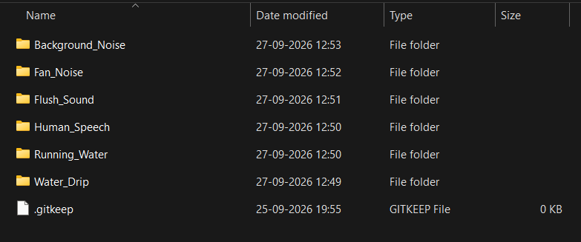
Figure 5.1: Class-wise folders of the audio dataset.
Long recordings are divided into one-second snippets. To keep a balance among the classes and to make the model less sensitive to a particular room or microphone position, light augmentation is added to the training data only: small time shifts, gain changes and low-level added noise. The held-out test set contains 66 segments, whose distribution over the classes is shown in Figure 5.2.
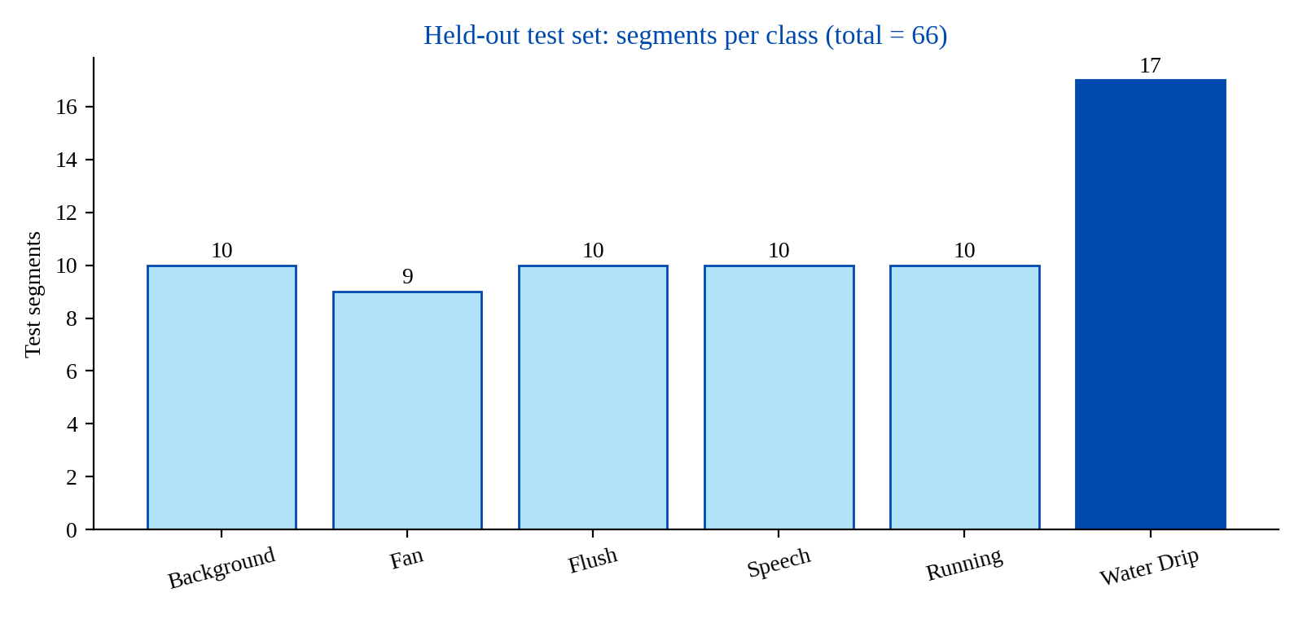
Figure 5.2: Number of test segments per class in the held-out test set.

5.3 Module 2: Audio Pre-processing
Objective: to improve audio quality and prepare the sound signals for feature extraction.
Raw audio contains much information that the classifier does not need. It is prepared for the network in four steps. Resampling converts all clips to 22,050 Hz, so that the format is the same for ESP32 recordings, smartphone recordings and ESC-50 clips. Noise reduction removes steady background noise. Normalisation scales the amplitude so that the model responds to the pattern of the sound and not to how loud it is. Segmentation divides the stream into one-second chunks. This chain follows the spirit of the pre-processing in [2], where spectra were normalised before classification. The implementation uses Librosa to load the audio. Table 5.2 summarises these steps and their purpose.
Table 5.2: Pre-processing steps and their purpose.
Step | Operation | Purpose
1 | Load audio with Librosa | Read WAV files into floating-point arrays
2 | Remove unwanted noise | Suppress steady background noise
3 | Normalise amplitude | Make the model independent of loudness
4 | Resample to 22,050 Hz | Common sampling rate for all sources
5 | Segment into 1-second chunks | Fixed-size model input and fast decisions

5.4 Module 3: Feature Extraction
Objective: to convert audio signals into numerical features suitable for AI model training.
Mel Frequency Cepstral Coefficients (MFCCs) describe the spectral shape of a sound on a scale that is close to human hearing [14]. Each segment is windowed and transformed with an FFT, filtered by a mel filter bank, and the log filter-bank energies are converted into cepstral coefficients. The mel mapping and the coefficients are:
m = 2595 · log₁₀(1 + f / 700) (5.1)
c_{n} = Σ_{k} log(S_{k}) · cos[ n(k − ½)π / K ] (5.2)
where S_{k} is the energy of the k-th mel filter and K is the number of filters. Forty coefficients are kept per frame. With an FFT size of 2048 and a hop of 512 samples, each one-second segment at 22,050 Hz provides 44 frames, so every segment becomes a 40 × 44 map that the CNN uses as a single-channel image. The extraction pipeline is shown in Figure 5.3. The parameters used are listed in Table 5.3.
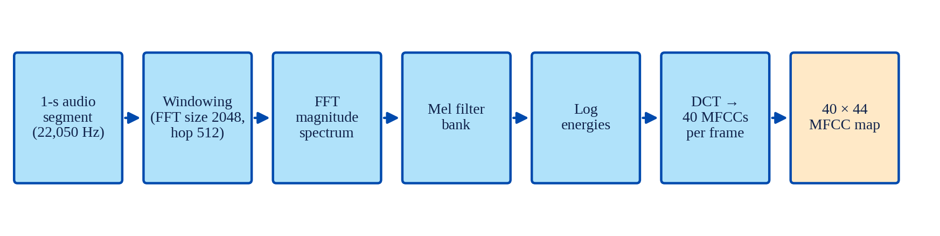
Figure 5.3: MFCC feature extraction pipeline.
Table 5.3: MFCC extraction parameters.
Parameter | Value
Sampling rate | 22,050 Hz
Segment length | 1 second
FFT size | 2048
Hop length | 512 samples
MFCC coefficients per frame | 40
Frames per segment | 44
Network input | 40 × 44 single-channel map

MFCCs were preferred over raw FFT magnitudes, as used in [2], because the mel scale compresses the high-frequency range and provides a compact 40-value description of each frame, which helps to keep the network small.

5.5 Module 4: CNN Model Development
Objective: to classify water leakage sounds using a deep learning model.
A CNN suits this task because its filters learn small time–frequency patterns directly from the MFCC map [15]. The broadband hiss of running water, the short isolated clicks of a drip, the harmonic bands of a voice and the steady hum of a fan all look different in that map. The network, shown in Figure 5.4 and detailed in Table 5.4, has two convolution–pooling blocks (32 and 64 filters of size 3 × 3, each with ReLU and followed by 2 × 2 max pooling), then a dense layer of 128 units, dropout, and a six-way softmax output.
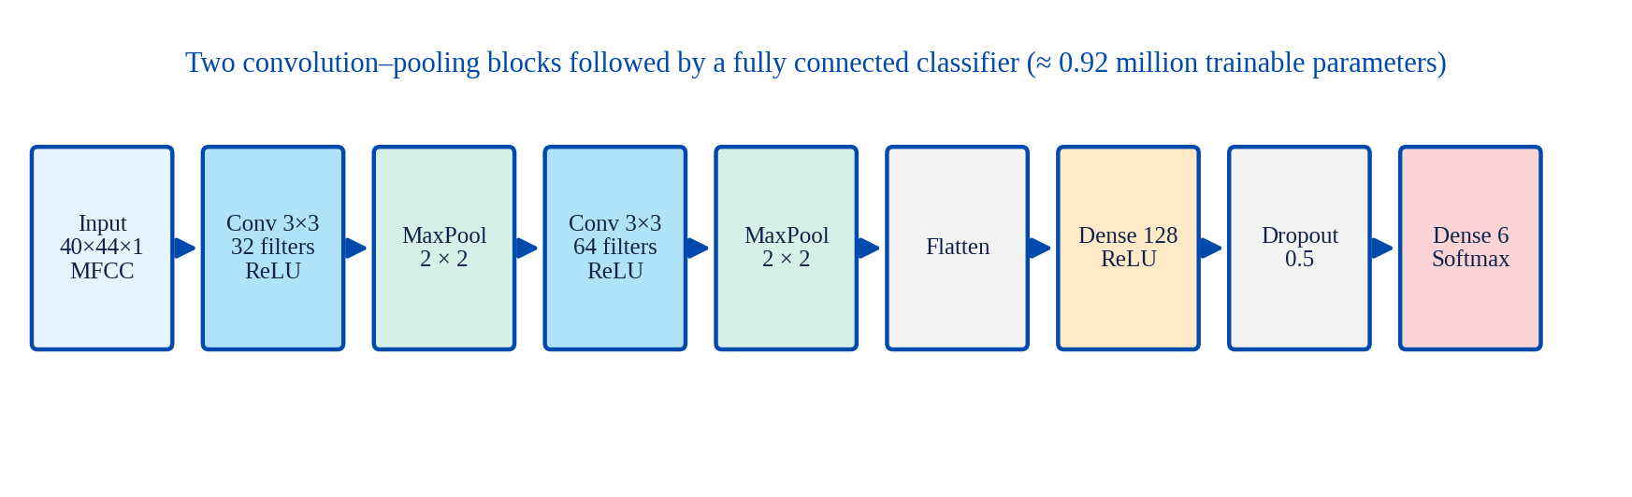
Figure 5.4: Architecture of the CNN classifier.
Table 5.4: Layer-wise summary of the CNN (shapes assume “same” padding).
Layer | Output shape | Parameters
Input (MFCC map) | 40 × 44 × 1 | 0
Conv2D, 32 filters, 3 × 3, ReLU | 40 × 44 × 32 | 320
MaxPooling2D, 2 × 2 | 20 × 22 × 32 | 0
Conv2D, 64 filters, 3 × 3, ReLU | 20 × 22 × 64 | 18,496
MaxPooling2D, 2 × 2 | 10 × 11 × 64 | 0
Flatten | 7,040 | 0
Dense, 128 units, ReLU | 128 | 901,248
Dropout (0.5) | 128 | 0
Dense, 6 units, softmax | 6 | 774
Total trainable parameters |  | 920,838 (≈ 0.92 M)

Most of the trainable parameters are in the dense layer, which is why dropout is applied there. Dropout randomly switches off units during training and helps to prevent the network from memorising a small data set [16]. Two convolution blocks are enough for a 40 × 44 input; a deeper stack would add parameters with little additional information to learn from, since the data set is modest in size. The 3 × 3 kernel gathers a couple of adjacent mel bands over a couple of frames, which is about the scale of a single drip. The one-second segment is a compromise: it is long enough to contain several drips in a typical leak, so that the decision logic can respond in a matter of seconds.
The model is trained with the Adam optimiser [17] and the categorical cross-entropy loss using the settings in Table 5.5. A small part of the training data is kept as a validation set and monitored over the 50 epochs. The test portion is used only once, at the end. As in [2], segments cut from the same recording session are kept on the same side of the split, because neighbouring segments are almost identical and would otherwise inflate the test score.
Table 5.5: Training configuration.
Parameter | Value
Epochs | 50
Batch size | 32
Optimiser | Adam
Loss function | Categorical cross-entropy
Data split | 80% training, 20% testing
Input | 40 × 44 MFCC map
Dropout rate | 0.5 (dense layer only)

Figure 5.5 shows the console output of the evaluation run. It reports the per-class results of the CNN and the overall accuracy of both models (MFCC model 0.9242, CNN 0.9697). The learning rate at the end of the run was 2.5 × 10⁻⁴.
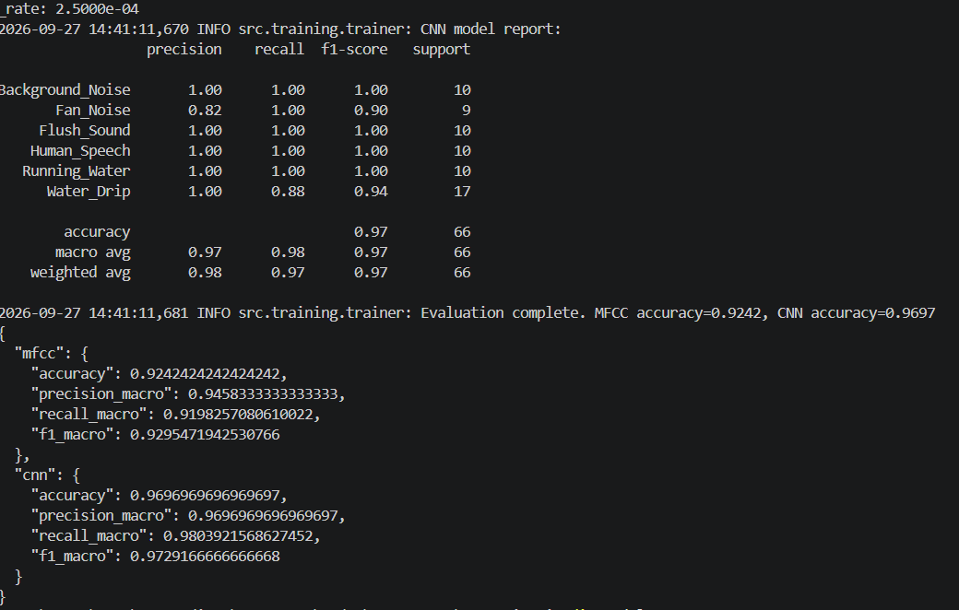
Figure 5.5: Console output of the evaluation run showing the CNN classification report and the MFCC and CNN summary metrics.

5.6 Module 5: Hardware Integration
Objective: to acquire acoustic signals and generate real-time leak alerts.
The ESP32 controller was selected, the INMP441 microphone sensor was integrated, a buzzer was connected for local alerts and the hardware communication architecture was designed (Figure 4.4). The hardware prototype comprises the ESP32 development board, the INMP441 microphone sensor, the buzzer alert system and the power supply unit. The ESP32 reads 16-bit samples through its I²S peripheral and uploads them in short chunks to the processing service, then drives the buzzer according to the status message that it receives. Full end-to-end operation of the node with the model and the cloud is the focus of Phase 02.

5.7 Module 6: Firebase Integration
Objective: to store leak events and support remote monitoring.
A Firebase project was created, the cloud database structure was designed, real-time data synchronisation was configured and the leak event storage schema (Figure 4.6 and Table 4.6) was prepared. Firebase provides the three services the system needs from the cloud: storage of events, push notification to the user and real-time data for the dashboard. Connecting the live service output to these Firebase functions is being completed.

5.8 Module 7: Dashboard Development
Objective: to provide real-time visualisation and monitoring of leak events.
The dashboard, named AquaSense, was implemented as a web application in React JS. Login and registration pages restrict access to registered users. The landing page (Figure 5.6) presents the system as a smart water leak monitoring platform and shows an acoustic waveform view of live decibel and frequency readings from the user’s sensor nodes. The leak history and analytics modules and the monitoring features are accessible after sign-in.
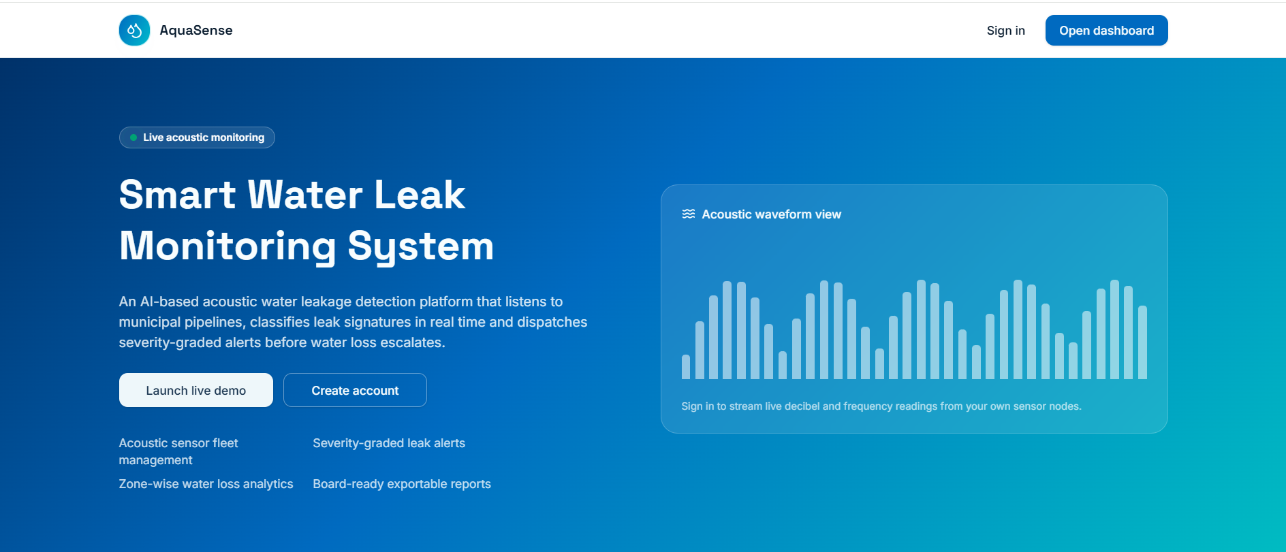
Figure 5.6: Landing page of the AquaSense dashboard.
The platform capabilities page lists the features of the dashboard: AI acoustic classification, real-time monitoring with threshold-breach alerts, instant severity-graded notifications, analytics and exportable reports, device health (battery, signal and firmware telemetry) and role-based access with admin, engineer and viewer roles backed by secure cloud authentication.
The dashboard also includes an Audio Leak Detection page, where the user uploads a recording (WAV, MP3, M4A, OGG, AAC, FLAC or WEBM, up to 10 MB) and presses “Detect leak”. The page replays the audio, draws a sound-level curve, and returns a verdict, a confidence bar and a one-line justification. This page was used to demonstrate the classifier and is discussed in Chapter 6.

5.9 Module 8: Notification System
Objective: to provide immediate alerts when leakage is detected.
The leak confirmation logic (Section 4.8) was defined, the buzzer alarm mechanism was configured, the notification workflow was designed and the integration of alerts with the dashboard was planned. The remaining work is to connect the confirmed-leak event to the Firebase notification and to verify the delivery time on a smartphone.

5.10 Working of the Prototype
In the working demonstration, the microphone captures the sound, the audio is processed and converted into MFCC features, the CNN analyses the pattern and identifies the leak sound, the buzzer alert is activated, the leak information is sent to Firebase, and the dashboard displays the leak status and notifications.

CHAPTER 6
RESULTS AND DISCUSSION

6.1 Evaluation Plan and Metrics
The trained model is first tested against the held-out 20% test set. It is then to be tested with real taps in real time using the ESP32 node. The live tests include a slowly dripping tap, a tap in normal use, speaking close to the microphone, a running fan and a toilet flush. For each of these a record is kept of whether the proper class and alert decision were produced, together with the delay between the drip crossing T_{leak} and the notification reaching the phone, and the number of false alarms during long unattended monitoring. In Phase 01 the first step, the test-set evaluation, has been completed; the live tests belong to Phase 02.
Accuracy, precision, recall and F1-score are calculated per class and on average. With TP, TN, FP and FN denoting the numbers of true positives, true negatives, false positives and false negatives:
Accuracy = (TP + TN) / (TP + TN + FP + FN) (6.1)
Precision = TP / (TP + FP) (6.2)
Recall = TP / (TP + FN) (6.3)
F1 = 2 · Precision · Recall / (Precision + Recall) (6.4)
Precision is the proportion of positive predictions that are correct, and recall is the proportion of actual positives that are found. The F1-score is the harmonic mean of the two and is high only when both are high. For the water-drip class, precision tells how many leak alarms are genuine, while recall tells how many real drip segments are detected.

6.2 Results of the CNN Model
The per-class results of the CNN on the 66-segment test set are listed in Table 6.1 and shown in Figure 6.1. The overall accuracy is 96.97%, which corresponds to 64 correct predictions out of 66. Background noise, flush sound, human speech and running water were all classified perfectly, with precision, recall and F1-score of 1.00.
Table 6.1: Per-class results of the CNN model on the test set.
Class | Precision | Recall | F1-score | Support
Background Noise | 1.00 | 1.00 | 1.00 | 10
Fan Noise | 0.82 | 1.00 | 0.90 | 9
Flush Sound | 1.00 | 1.00 | 1.00 | 10
Human Speech | 1.00 | 1.00 | 1.00 | 10
Running Water | 1.00 | 1.00 | 1.00 | 10
Water Drip | 1.00 | 0.88 | 0.94 | 17
Accuracy |  |  | 0.97 | 66
Macro average | 0.97 | 0.98 | 0.97 | 66
Weighted average | 0.98 | 0.97 | 0.97 | 66

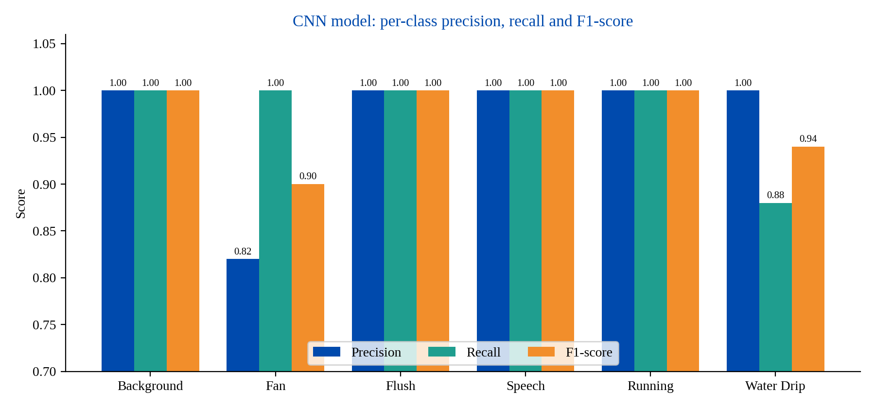
Figure 6.1: Per-class precision, recall and F1-score of the CNN model. The y-axis starts at 0.70, not at zero.
The water-drip class has a precision of 1.00, which means that every leak prediction was correct and there were no false leak alarms. Its recall of 0.88 means that 88% of the actual leak sounds were detected, and the F1-score of 0.94 shows an excellent balance. Fan noise has a recall of 1.00 but a precision of 0.82 (F1-score 0.90), so some segments of other classes were labelled as fan. The only other class with a recall below 1.00 is the water drip, and these misses are normally faint drips that are interpreted as fan noise.
Because precision and recall are reported with the number of test segments per class, the underlying confusion matrix can be reconstructed. It is shown in Figure 6.2 and confirms that the only errors made by the CNN were two drip segments predicted as fan noise.
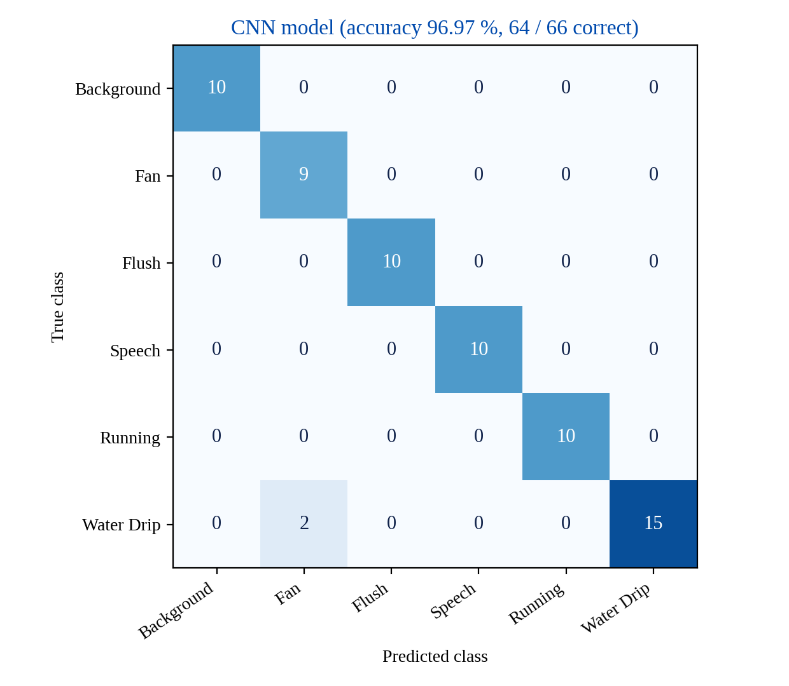
Figure 6.2: Confusion matrix of the CNN model, reconstructed from the per-class precision, recall and support values.

6.3 Results of the MFCC Model
In addition to the CNN, a baseline model that works on the MFCC feature vectors was trained so that the choice of the final classifier is based on a comparison and is not assumed. Its results are listed in Table 6.2. Flush sound, human speech and running water are again classified perfectly. The precision of background noise is 1.00 but its recall is 0.80, so 20% of the background segments were mislabelled. Fan noise has a precision of 0.88 and a recall of 0.78. For the leak class, water drip has a recall of 0.94 but a precision of 0.80: 94% of the actual drips were found, but some non-leak sounds were also labelled as leaks, which in a deployed node would appear as false alarms. The reconstructed confusion matrix in Figure 6.3 shows that the five errors of this model are two background and two fan segments predicted as drip, and one drip segment predicted as fan.
Table 6.2: Per-class results of the MFCC model on the test set.
Class | Precision | Recall | F1-score | Support
Background Noise | 1.00 | 0.80 | 0.89 | 10
Fan Noise | 0.88 | 0.78 | 0.82 | 9
Flush Sound | 1.00 | 1.00 | 1.00 | 10
Human Speech | 1.00 | 1.00 | 1.00 | 10
Running Water | 1.00 | 1.00 | 1.00 | 10
Water Drip | 0.80 | 0.94 | 0.86 | 17
Accuracy |  |  | 0.92 | 66
Macro average | 0.95 | 0.92 | 0.93 | 66
Weighted average | 0.93 | 0.92 | 0.92 | 66

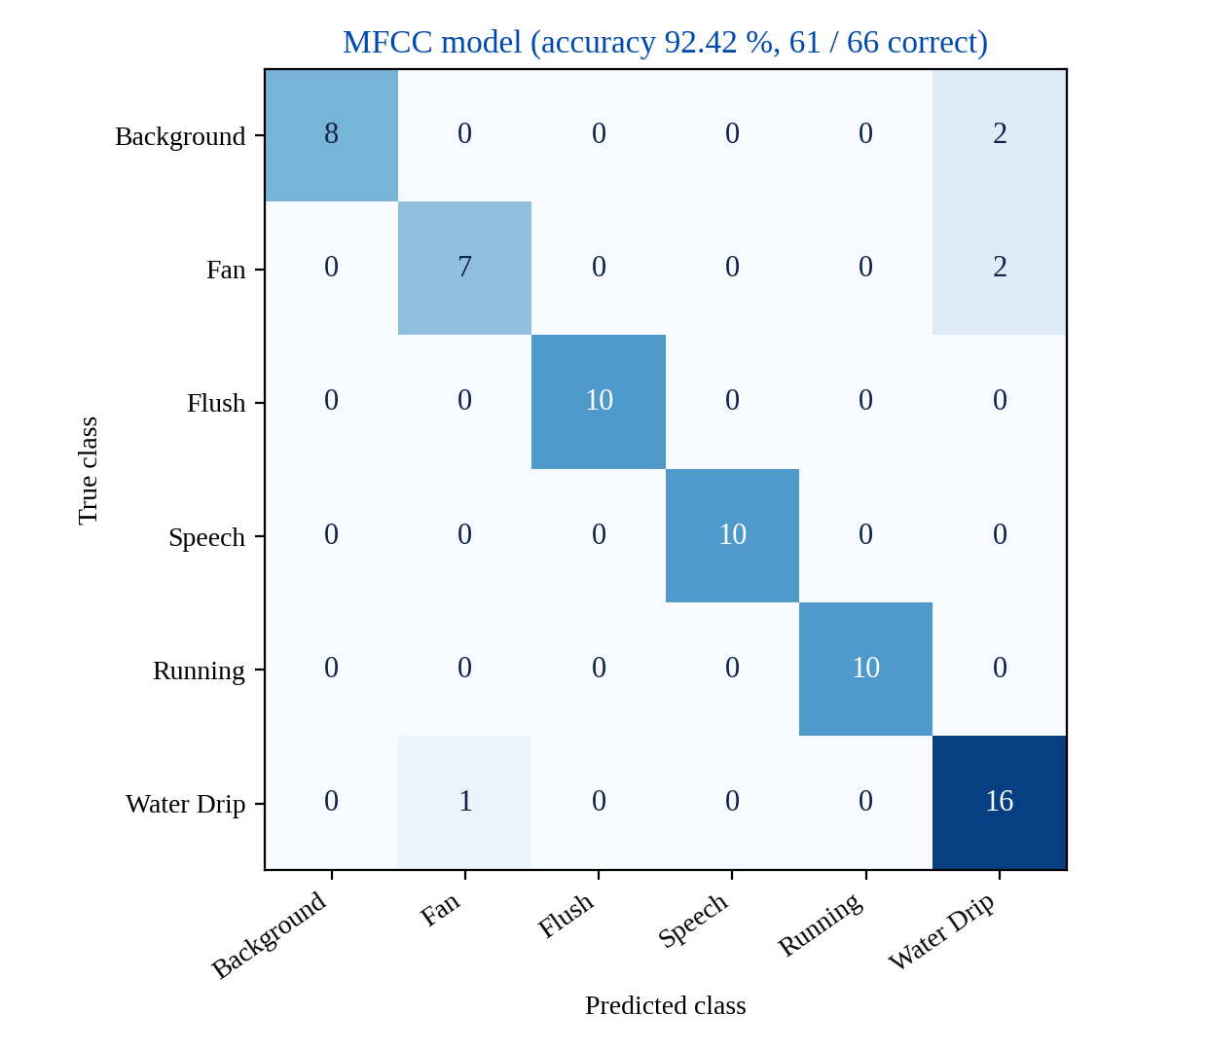
Figure 6.3: Confusion matrix of the MFCC model, reconstructed from the per-class precision, recall and support values.

6.4 Comparison of the MFCC and CNN Models
The overall comparison of the two models is given in Table 6.3 and Figures 6.4 and 6.5. The CNN is ahead on all four metrics: accuracy 96.97% versus 92.42%, precision 96.97% versus 94.58%, recall 98.04% versus 91.98% and F1-score 97.29% versus 92.95%. The largest difference is in macro recall, of about 6 points. The gap in macro precision is smaller, about 2.4 points. Both models are above the 90% target line.
Table 6.3: Overall comparison of the MFCC and CNN models (accuracy and macro-averaged precision, recall and F1-score).
Metric | MFCC model | CNN model
Accuracy | 92.42% | 96.97%
Precision | 94.58% | 96.97%
Recall | 91.98% | 98.04%
F1-score | 92.95% | 97.29%

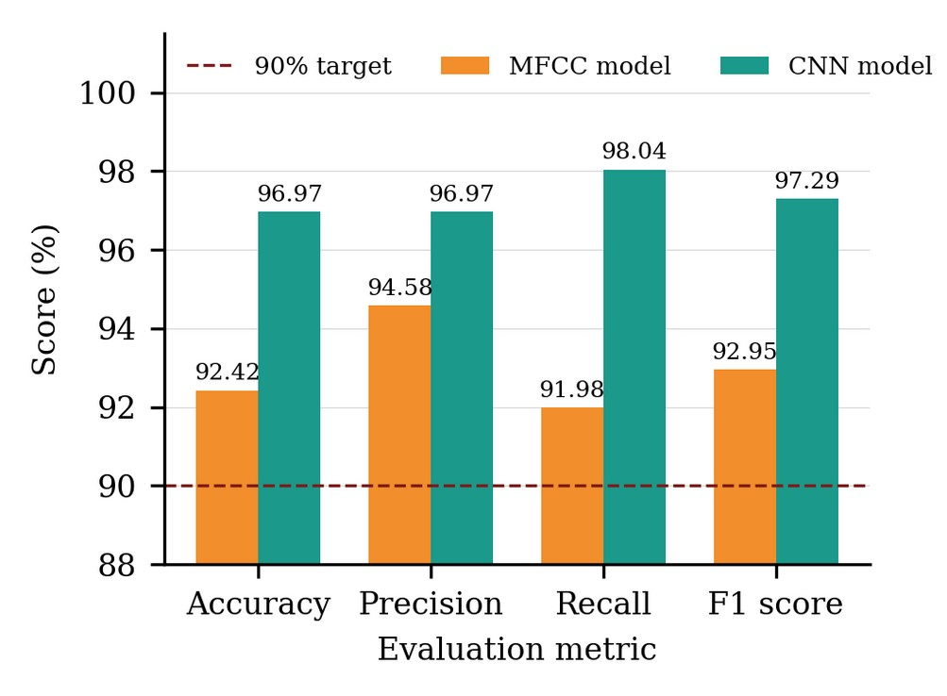
Figure 6.4: Overall accuracy, precision, recall and F1-score of the MFCC model (orange) and the CNN model (teal). The y-axis starts at 88%, not at zero.
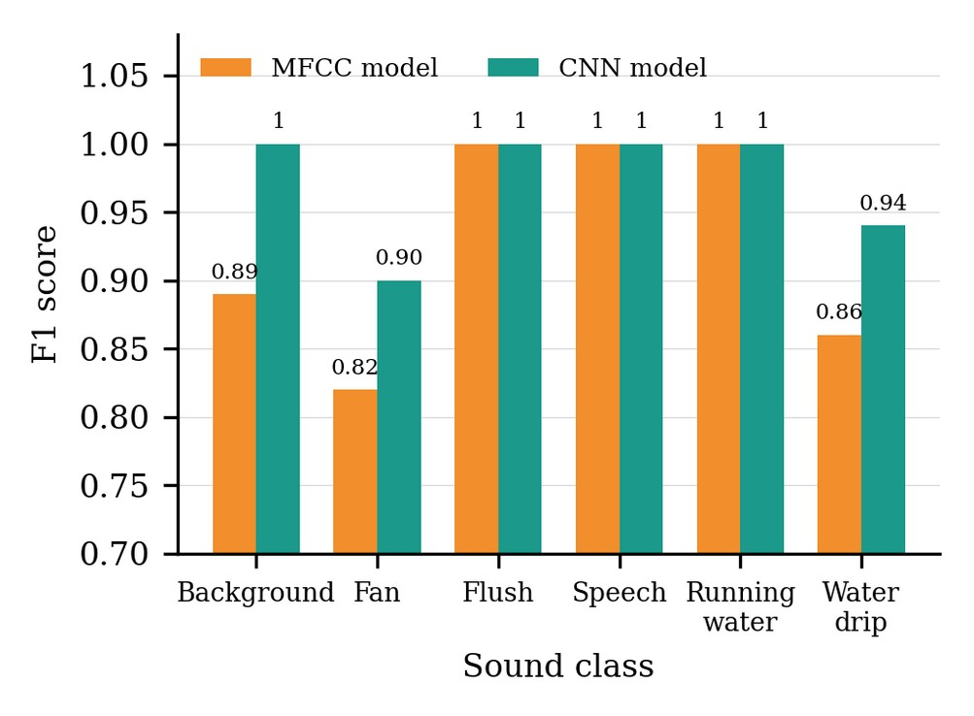
Figure 6.5: F1-score per class of the MFCC model (orange) and the CNN model (teal). The y-axis starts at 0.70, not at zero.
Figure 6.4 starts the y-axis at 88%, so the gaps between the bars look larger than they are; the printed values are accurate. Figure 6.5 shows that the frequencies of flush sound, human speech and running water are classified equally well by both models (F1 = 1.00). The CNN improves background noise from 0.89 to 1.00 and water drip from 0.86 to 0.94, and fan noise rises from 0.82 to 0.90. Fan noise stays the weakest class for both models, which agrees with the confusion that was expected between fan noise and faint drips or quiet background.
The CNN gives up a little drip recall (0.88 versus 0.94) in exchange for a large gain in drip precision (1.00 versus 0.80). For a monitoring node whose primary concern is false alarms, this is the more favourable exchange. The lost recall is partly covered by the confirmation rule: because a leak is declared after a series of positive segments, and because the grace period lets a few missed segments pass, a negative segment does not cancel a previous positive run, and at most the alert comes a little later. The CNN is therefore used in the final system.

6.5 Target versus Measured Performance
Table 6.4 compares the targets set in the evaluation plan with the values obtained on the test set. The CNN reaches an accuracy above the expected 90–95% range. This range was chosen as realistic and not pessimistic: the CNN and DNN in [2] reached about 94.7–94.9% on a two-class leak versus no-leak task, and the edge model in [11] reported 98.96%, whereas the present task has six classes and a noisier environment.
Table 6.4: Target and measured performance of the CNN model.
Metric | Target | Measured
Accuracy | 90–95% | 96.97%
Precision | > 90% | 96.97%
Recall | > 90% | 98.04%
F1-score | > 90% | 97.29%
False alarms per day | Minimal | 0 false drip predictions on the test set (precision 1.00); live confirmation pending
Alert delay after T_{leak} | Near real time | about 1–2 s (preliminary); live confirmation pending

It should be noted that the false-alarm and alert-delay entries of Table 6.4 describe the whole chain and not only the classifier. They will be confirmed by extended live testing at actual taps in Phase 02.

6.6 Prototype Demonstration on the Dashboard
The recording-analysis page of the dashboard was used to demonstrate the classifier. The user uploads an audio file and presses Detect leak. Figures 6.6 and 6.7 show the two outcomes. These runs use uploaded recordings, captured by other devices or downloaded from the internet, and not audio captured in real time by the ESP32 node.
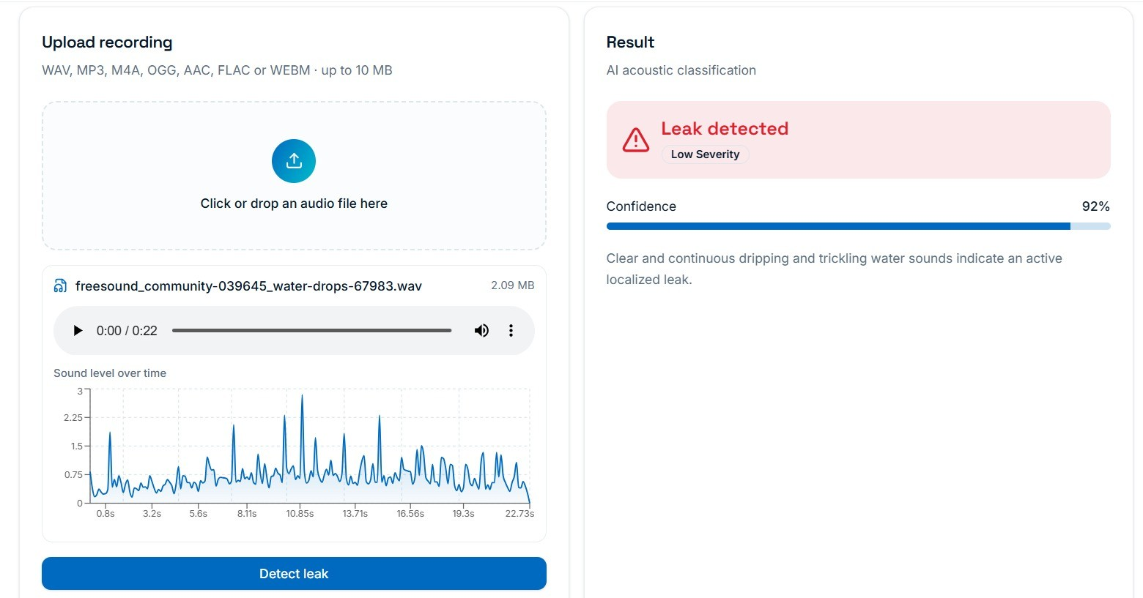
Figure 6.6: Analysis page for a dripping-water recording (22.7 s, 2.09 MB): “Leak detected” with 92% confidence.
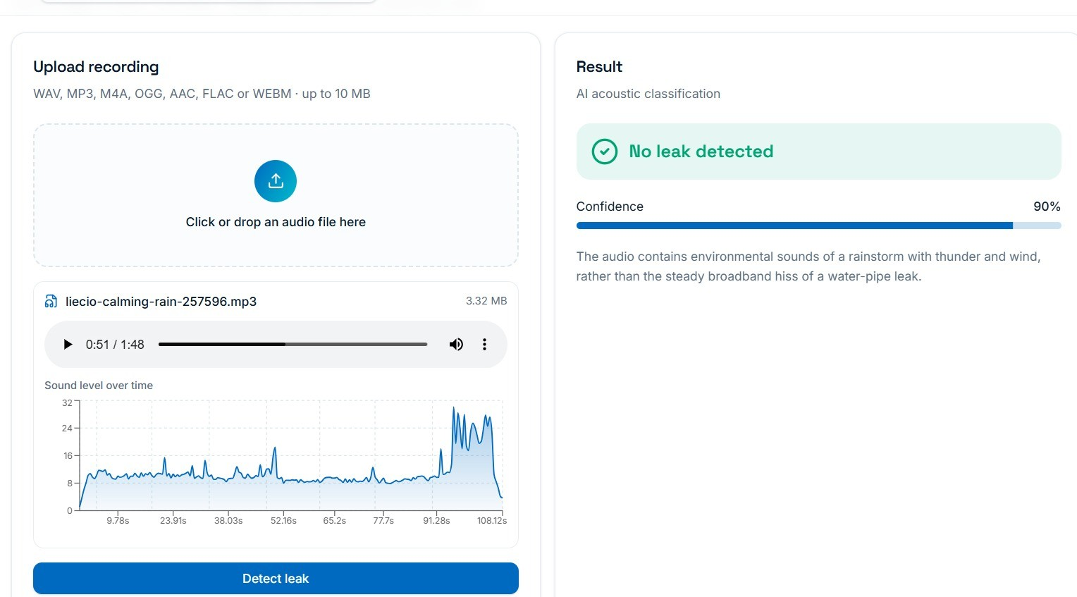
Figure 6.7: Analysis page for a rain recording (1 min 48 s, 3.32 MB): “No leak detected” with 90% confidence.

6.6.1 Understanding the Sound-Level Graphs
In both figures the horizontal axis measures time in seconds from the beginning of the recording, and the vertical axis is the loudness of the sound, a relative measure that increases with the strength of the sound. In Figure 6.6 the curve stays low, mostly between about 0.25 and 0.75, and is interrupted by thin peaks that rise to between 1.5 and 2.8. Each peak corresponds to one drop hitting the basin. The peaks are isolated and irregular, and the signal is a train of short impulses repeated throughout the 22 seconds, rather than a continuous hiss. This is the pattern that the CNN labels as drip; because it persists through the whole clip, it would pass the confirmation rule, and the severity is low because the leak has lasted only a short time.
The rain recording in Figure 6.7 is different. The level is nearly flat at a modest value with only slight variations, because many small drops overlap and cannot be distinguished, giving a continuous spectrum of sound. Towards the end of the clip the level rises sharply for a short time, corresponding to a burst of wind and thunder. The system reports no leak with 90% confidence, since the sound is ambient noise and not the isolated clicks of a drip.
The two graphs also reveal that loudness is not what decides the result. The vertical axis of Figure 6.6 ends at 3, while that of Figure 6.7 reaches more than ten times that value, so the rain clip is many times louder, yet it is the quiet drip clip that is flagged. This agrees with the design in Section 5.3: amplitude is normalised so that the model responds to the pattern of the sound and not to its level. The two curves should therefore not be compared solely on height.

6.7 Live Test Scenarios
To check the whole chain and not only the classifier, the scenarios in Table 6.5 will be run during the live-testing stage. Each has an expected class and an expected response from the system. A scenario passes only if both the classification and the alert decision are right. For example, an alarm should not go off if there is speech near the tap, and a running tap in normal use should not trigger the alarm.
Table 6.5: Live test scenarios planned for Phase 02.
Scenario | Expected class | Expected response
Slow drip, continuous | Water Drip | Alert after T_{leak}
Normal use | Running Water | No alert
Toilet flush | Flush Sound | No alert
Talking near the tap | Human Speech | No alert
Fan running | Fan Noise | No alert
Quiet room | Background | No alert
Drip while talking | Water Drip | Alert

6.8 Threats to Validity
Several factors may bias the results to appear more favourable than they are, and they should be kept in mind when reading the figures in this chapter.
- Source of the data. Public clips such as those in ESC-50 were not recorded with the INMP441, so a model trained mainly on them may behave differently on the actual device. This is why custom recordings are made at actual taps.
- Similar neighbouring segments. Segments from the same recording are very similar to each other, so the split keeps segments of one recording session on the same side.
- Small test set. The test set contains only 66 segments (17 of them drips), so a single segment changes the drip recall by about six percentage points. The results should be treated as promising and not as final.
- Single environment. A test set prepared from one set of rooms does not describe a new building. Where feasible, part of the test data will be recorded in a place the model has not heard.

CHAPTER 7
CHALLENGES, LIMITATIONS AND PROJECT STATUS

7.1 Challenges Faced
Three main challenges were faced during Phase 01, together with the solutions adopted. They are summarised in Table 7.1 and discussed below.
Table 7.1: Challenges faced and the solutions adopted.
Challenge | Issue | Solution
1. Limited water leak dataset | Publicly available water drip datasets are limited. | Combined the ESC-50 dataset with custom audio recordings.
2. Similarity between leak and water-flow sounds | Leak sounds and normal water flow sounds have similar acoustic characteristics. | Used MFCC feature extraction and CNN-based classification to identify unique sound patterns.
3. Hardware–software integration | Integration between the ESP32, the AI model, Firebase and the dashboard is still under development. | Adopted a modular architecture for easier implementation and testing.

7.1.1 Limited Dataset
Drip sounds at taps are not well represented in public collections, and those that exist were recorded with different microphones and in different rooms. By combining ESC-50 with recordings made at real taps at various flow rates and distances, the training data became closer to what the deployed microphone will hear. The dataset is nevertheless modest in size, and enlarging it with field recordings is a priority for the next phase.

7.1.2 Similarity of Leak and Flow Sounds
A drip and a thin stream of running water, a flush, a fan and speech all overlap in frequency. A plain energy threshold would confuse them. MFCC features describe the spectral shape of the sound, and the CNN learns the small time–frequency patterns that separate the isolated clicks of a drip from the broadband hiss of flow, the harmonic bands of speech and the steady hum of a fan.

7.1.3 Hardware–Software Integration
The chain from the ESP32 to the AI service, Firebase and the dashboard involves four separate technologies. Rather than integrating everything at once, the system was designed as independent modules with clear interfaces, so that each module could be implemented and tested alone. This allowed the AI and dashboard modules to be completed while the hardware, Firebase and notification modules are still being integrated.

7.2 Limitations
The technique has definite bounds, and the following limitations should be understood.
- Very faint drips. A very light dribble can be close to the noise floor, and a loud room can obscure it. The missed drips of the CNN are typically faint ones interpreted as fan noise.
- Microphone position. The location of the microphone alters the sound it receives, so some fine tuning may be needed for each installation.
- Network dependence. Because audio is sent to a server, the node depends on its Wi-Fi connection.
- Privacy. A microphone in a washroom could record speech. Only features and predictions should be retained by the service, and raw audio should be discarded immediately after MFCC extraction. It should be made clear to users that the device is listening.
- Tap left fully open. A tap that is fully open is a wasteful use but is treated as normal running water. If this case must be covered, a separate long-duration rule can be added.

7.3 Cost and Energy
The bill of materials is simple: a microcontroller board, a small microphone breakout and a buzzer. The server side can run on any small machine or on a shared cloud instance that serves many nodes at once, so the cost per tap falls as more taps are added. The node uses power from a mains adapter and does not need battery maintenance. Despite its Wi-Fi capability, the present design is not a good choice for battery operation because the radio is used to stream audio. Moving the inference to the ESP32, as suggested in Chapter 8, would keep the radio idle for most of the time and would open the way to battery operation.

7.4 Applications
The system is suitable for residential buildings and smart homes, hostels, offices, educational institutions, shopping complexes and public washrooms, that is, any place with many taps that no one is watching.

7.5 Deployment Considerations
There are a few more decisions to make for practical deployment. The distance of the microphone from the spout should be reproducible, so that the recorded level does not change from day to day. Each node should have an identifier and a readable location name. If several nodes share one server, the service should keep a separate run-length counter for each node, so that a drip at one tap is never mixed up with speech at another. Finally, new recordings from the field, after a person has confirmed whether a leak was real or not, can be added to the training set and used to retrain the model over time, in the same way that the authors of [2] used repaired-pipe results to relabel their data.

7.6 Project Status at the End of Phase 01
Table 7.2 lists the deliverables of Phase 01 and their status. The hardware prototype comprises the ESP32 development board, the INMP441 microphone sensor, the buzzer alert system and the power supply unit, while the software prototype comprises the audio dataset, the pre-processing module, the MFCC feature extraction module, the CNN model, the Firebase database set-up and the dashboard interface.
Table 7.2: Status of the Phase 01 deliverables.
Deliverable | Status | Remarks
Audio dataset collection | Completed | ESC-50 + custom recordings, class-wise WAV files
Audio pre-processing module | Completed | Resampling, noise removal, normalisation, segmentation
MFCC feature extraction module | Completed | 40 coefficients, 40 × 44 map
CNN model development | Completed | 96.97% accuracy on held-out test set
Dashboard | Completed | Login, dashboard, history, analytics, audio analysis page
Hardware integration | In progress | ESP32 + INMP441 + buzzer
Firebase integration | In progress | Schema ready; live connection under way
Notification system | In progress | Confirmation logic defined; delivery to be verified

CHAPTER 8
CONCLUSION AND FUTURE SCOPE

8.1 Conclusion
This report presented the Phase 01 work on an acoustic leak detection and notification system for taps. The system combines an INMP441 microphone and an ESP32 controller with MFCC features, a CNN classifier, a persistence-based confirmation rule, a buzzer, and Firebase-powered alerts and dashboard. By listening to the sound of a drip and ignoring familiar household sounds, the system aims to provide low-cost early warning of leaks that slip past flow and moisture sensors.
In Phase 01 the dataset was prepared from ESC-50 and custom recordings, an audio pre-processing and MFCC feature extraction pipeline was implemented, and a compact six-class CNN was trained and evaluated. The CNN achieved an overall accuracy of 96.97%, a drip precision of 1.00, a drip recall of 0.88 and a drip F1-score of 0.94 on the held-out test set, and it outperformed the MFCC baseline on accuracy, precision, recall and F1-score. The AquaSense dashboard was completed, and its audio analysis page demonstrated that the classifier separates a dripping tap from rain irrespective of loudness. The hardware, Firebase and notification modules have been designed and are being integrated.
The results should be read with care because the test set is small and the whole chain has not yet been tested at real taps. The next step is therefore to extend the live tests and to validate the measured values in Table 6.4.

8.2 Plan for Phase 02
The work planned for Phase 02 is listed in Table 8.1.
Table 8.1: Planned work for Phase 02.
Activity | Description
Complete hardware integration | Finalise ESP32 I²S audio capture, Wi-Fi upload to the FastAPI service and buzzer control.
Complete Firebase and notification modules | Connect confirmed-leak events to Firebase storage and push notification; verify delivery time on a phone.
Live testing at real taps | Run the scenarios of Table 6.5; measure false alarms per day and alert delay.
Expand the dataset | Record more drips at different taps, rooms and distances; include recordings from the INMP441.
Tune decision parameters | Select θ and T_{leak} per installation from recorded data.
Validate on unseen environments | Record part of the test data in places the model has not heard.

8.3 Future Scope
There are a number of possible extensions beyond Phase 02:
- TinyML on the ESP32. Running a compressed model directly on the ESP32 would remove the need for a separate server, help privacy because audio would not be streamed, and allow battery operation.
- Dedicated mobile application. A dedicated app could replace the generic push notification.
- Smart shut-off valve. A valve could shut off the supply automatically when a leak has been confirmed or when a dangerous level of water is detected.
- Multi-room deployment. The same design can be applied to several areas of a building, with one run-length counter for every node.
- Predictive maintenance. Stored history can be used to predict which taps are likely to fail and to plan maintenance.
- Long-duration rule. A separate rule can be added for taps left fully open, which are currently treated as normal running water.
- Continuous learning. Field recordings confirmed as real or false leaks can be added to the training set to retrain the model over time.

REFERENCES
[1] R. Frauendorfer and R. Liemberger, The Issues and Challenges of Reducing Non-Revenue Water. Mandaluyong, Philippines: Asian Development Bank, 2010.
[2] R. Vanijjirattikhan et al., “AI-based acoustic leak detection in water distribution systems,” Results in Engineering, vol. 15, Art. no. 100557, 2022, doi: 10.1016/j.rineng.2022.100557.
[3] S. El-Zahab and T. Zayed, “Leak detection in water distribution networks: an introductory overview,” Smart Water, vol. 4, no. 1, p. 5, 2019.
[4] R. Zese, E. Bellodi, C. Luciani, and S. Alvisi, “Neural network techniques for detecting intra-domestic water leaks of different magnitude,” IEEE Access, vol. 9, pp. 126135–126147, 2021, doi: 10.1109/ACCESS.2021.3111113.
[5] J. Kang, Y.-J. Park, J. Lee, S.-H. Wang, and D.-S. Eom, “Novel leakage detection by ensemble CNN-SVM and graph-based localization in water distribution systems,” IEEE Trans. Ind. Electron., vol. 65, no. 5, pp. 4279–4289, 2018.
[6] R. Müller et al., “Acoustic leak detection in water networks,” in Proc. 13th Int. Conf. Agents and Artificial Intelligence, SCITEPRESS, 2021.
[7] Y. W. Nam, Y. Arai, T. Kunizane, and A. Koizumi, “Water leak detection based on convolutional neural network using actual leak sounds and the hold-out method,” Water Supply, vol. 21, no. 7, pp. 3477–3485, 2021.
[8] P. Arunsuriyasak, P. Boonme, and P. Phasukkit, “Investigation of deep learning optimizer for water pipe leaking detection,” in Proc. 16th Int. Conf. ECTI-CON, 2019, pp. 85–88.
[9] A. Gunatilake and J. Valls, “Multimodel neural network for live classification of water pipe leaks from vibro-acoustic signals,” IEEE Sensors J., vol. 24, no. 9, pp. 14825–14832, 2024, doi: 10.1109/JSEN.2024.3379476.
[10] E. A. Martinez-Rios, D. Barrientos, and R. Bustamante, “Water leakage classification with acceleration, pressure, and acoustic data: leveraging the wavelet scattering transform, unimodal classifiers, and late fusion,” IEEE Access, vol. 12, pp. 84923–84951, 2024, doi: 10.1109/ACCESS.2024.3416056.
[11] M. R. Islam, S. Azam, B. Shanmugam, and D. Mathur, “An intelligent IoT and ML-based water leakage detection system,” IEEE Access, vol. 11, pp. 123625–123649, 2023, doi: 10.1109/ACCESS.2023.3329467.
[12] B. McFee et al., “librosa: Audio and music signal analysis in Python,” in Proc. 14th Python in Science Conf., 2015, pp. 18–25.
[13] K. J. Piczak, “ESC: Dataset for environmental sound classification,” in Proc. 23rd ACM Int. Conf. Multimedia, 2015, pp. 1015–1018.
[14] S. Davis and P. Mermelstein, “Comparison of parametric representations for monosyllabic word recognition in continuously spoken sentences,” IEEE Trans. Acoust., Speech, Signal Process., vol. 28, no. 4, pp. 357–366, 1980.
[15] Y. LeCun, Y. Bengio, and G. Hinton, “Deep learning,” Nature, vol. 521, no. 7553, pp. 436–444, 2015.
[16] N. Srivastava, G. Hinton, A. Krizhevsky, I. Sutskever, and R. Salakhutdinov, “Dropout: a simple way to prevent neural networks from overfitting,” J. Mach. Learn. Res., vol. 15, no. 56, pp. 1929–1958, 2014.
[17] D. P. Kingma and J. Ba, “Adam: A method for stochastic optimization,” in Proc. Int. Conf. Learning Representations (ICLR), 2015.

APPENDIX – A: SOURCE CODE

audio-detect.functions.ts :

import { createServerFn } from "@tanstack/react-start";
import { z } from "zod";
const FORMATS = ["wav", "mp3", "webm", "m4a", "ogg", "aac", "flac"] as const;
export type DetectionResult = {
leak: boolean;
confidence: number;
severity: "none" | "low" | "medium" | "high" | "critical";
explanation: string;
};
export const detectLeakFromAudio = createServerFn({ method: "POST" })
.inputValidator((d) =>
.object({
base64: z.string().min(10).max(14_000_000),
format: z.enum(FORMATS),
})
.parse(d),
)
.handler(async ({ data }): Promise<DetectionResult> => {
const key = process.env["LOVABLE_API_KEY"];
if (!key) throw new Error("AI service is not configured.");

const res = await fetch("https://ai.gateway.lovable.dev/v1/chat/completions", {
method: "POST",
headers: { Authorization: `Bearer ${key}`, "Content-Type": "application/json" },
body: JSON.stringify({
model: "google/gemini-3.5-flash",
response_format: { type: "json_object" },
messages: [
{
role: "system",
content:
"You are an acoustic water-pipe leak detection classifier. Listen to the audio and decide whether it contains signatures of a water leak (continuous hissing, broadband noise, spraying, dripping, rushing water, pipe vibration). Reply ONLY with JSON: {\"leak\": boolean, \"confidence\": number 0-100, \"severity\": \"none\"|\"low\"|\"medium\"|\"high\"|\"critical\", \"explanation\": short string under 40 words}. Use severity \"none\" when leak is false.",
},
{
role: "user",
content: [
{ type: "text", text: "Classify this recording." },
{ type: "input_audio", input_audio: { data: data.base64, format: data.format } },
],
},
],
}),
});

if (!res.ok) {
if (res.status === 429) throw new Error("Too many requests right now. Please wait a moment and try again.");
if (res.status === 402) throw new Error("AI credits have run out. Please add credits to continue.");
const t = await res.text();
throw new Error(`Analysis failed (${res.status}). ${t.slice(0, 200)}`);
}
const json = await res.json();
const text: string = json?.choices?.[0]?.message?.content ?? "";
if (!text) throw new Error("The AI could not analyse this recording.");
const match = text.match(/\{[\s\S]*\}/);
const parsed = JSON.parse(match ? match[0] : text);
return {
leak: Boolean(parsed.leak),
confidence: Math.max(0, Math.min(100, Number(parsed.confidence) || 0)),
severity: parsed.severity ?? (parsed.leak ? "medium" : "none"),
explanation: String(parsed.explanation ?? ""),
};
});
AudioUpload.tsx :
import { useState } from "react";
import { detectLeakFromAudio } from "@/lib/audio-detect.functions";
type DetectionResult = {
leak: boolean;
confidence: number;
severity: "none" | "low" | "medium" | "high" | "critical";
explanation: string;
};
export default function AudioUpload() {
const [file, setFile] = useState<File | null>(null);
const [result, setResult] = useState<DetectionResult | null>(null);
const [loading, setLoading] = useState(false);
const [error, setError] = useState("");
async function handleDetection() {
if (!file) {
setError("Please upload an audio recording.");
return;
}
setLoading(true);
setError("");
setResult(null);
try {
const extension = file.name.split(".").pop()?.toLowerCase();
const formats = [
"wav", "mp3", "webm", "m4a", "ogg", "aac", "flac",
] as const;
if (!extension || !formats.includes(extension as typeof formats[number])) {
throw new Error("Unsupported audio format.");
}
const base64 = await new Promise<string>((resolve, reject) => {
const reader = new FileReader();
reader.onload = () => {
const value = reader.result;
if (typeof value !== "string") {
reject(new Error("Unable to read the audio file."));
return;
}
resolve(value.split(",")[1]);
};

reader.onerror = () =>
reject(new Error("Failed to read the audio file."));
reader.readAsDataURL(file);
});
const response = await detectLeakFromAudio({
data: {
base64,
format: extension as typeof formats[number],
},
});
setResult(response);
} catch (err) {
setError(
err instanceof Error ? err.message : "Audio analysis failed."
);
} finally {
setLoading(false);
}
}
return (
<section>
<h2>Water Leak Detection</h2>
<input
type="file"
accept="audio/*"
onChange={(event) => {
setFile(event.target.files?.[0] ?? null);
setResult(null);
setError("");
}}
/>
<button
type="button"
onClick={handleDetection}
disabled={!file || loading}
>
{loading ? "Analyzing audio..." : "Detect leak"}
</button
{error && <p role="alert">{error}</p>}
{result && (
<div>
<h3>Detection Result</h3>
<p>Status: {result.leak ? "Possible Leak" : "No Leak Detected"}</p>
<p>Confidence: {result.confidence}%</p>
<p>Severity: {result.severity}</p>
<p>Explanation: {result.explanation}</p>
</div>
)}
</section>
);
}
APPENDIX – B: SAMPLE OUTPUTS & DASHBOARD SCREENSHOTS
Webpage :
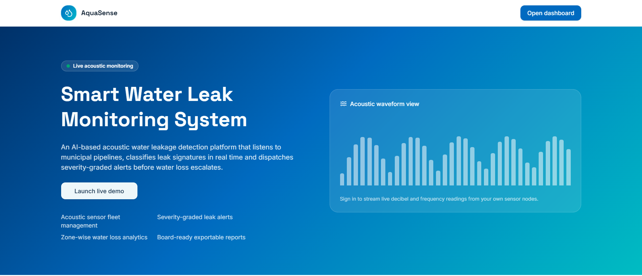
No Leak Detected :
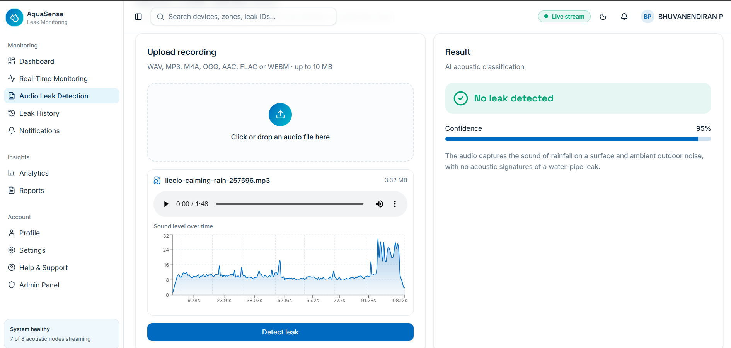
Leak Detected :
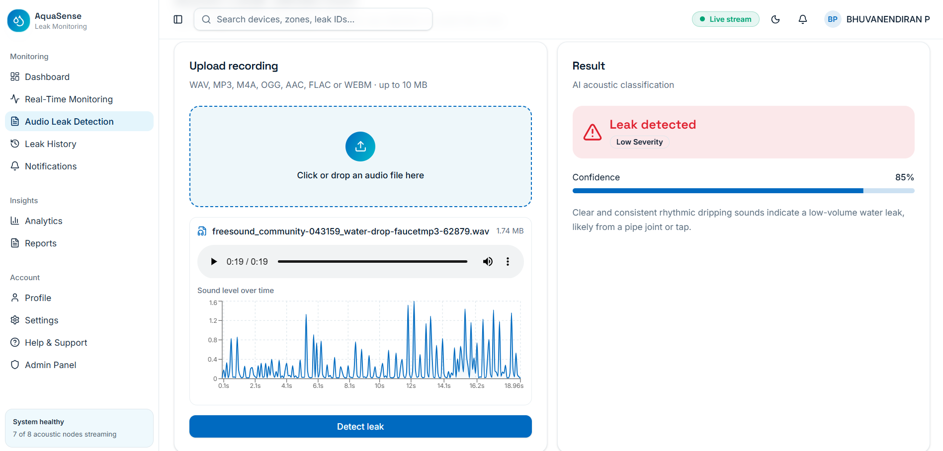
APPENDIX – C: CONFERENCE APPLICATION

Conference: International Conference on Computation, Communication, AND Intelligent Systems in Engineering
Paper ID: 844
Paper: Acoustic-Based Water Leakage Detection and Notification System Using Convolutional Neural Networks

